Python Statistical Analytics

A Comprehensive Practical Training Guide
Prepared by: Kajola Gbenga
Data Scientist & AI Engineer

This guide is the full companion document to the training kit’s Jupyter notebook, Excel workbook, and CSV datasets. It reproduces every section of the practical with the underlying statistical theory explained in full, the exact Python code used, a line-by-line breakdown of what each line of code does, and the actual chart produced by running that code. It is designed so a class can be taught directly from this document even without opening the notebook, while remaining perfectly consistent with it.
Companion files in this training kit:
- employee_statistics_dataset.csv - the 400-row cross-sectional dataset used throughout Sections 1-23.
- monthly_revenue_timeseries.csv - the 60-month time series used in Section 24.
- python_statistical_analytics_workbook.xlsx - the same two datasets plus live Excel-formula statistics, frequency tables, a correlation matrix, group comparisons, and charts.
- Python_Statistical_Analytics_Practical.ipynb - the executable Jupyter notebook this guide is built from.
- Python_Statistical_Analytics_Guide.html - a browser-viewable version of this same guide.

Table of Contents
- Environment Setup
- Loading and Inspecting the Data
- Data Cleaning - Missing Values, Duplicates, Data Types
- Descriptive (Summary) Statistics
- Measures of Shape - Skewness and Kurtosis
- Data Visualization for Statistics
- Probability Distributions
- Sampling and the Central Limit Theorem
- Confidence Intervals
- Hypothesis Testing - One-Sample and Two-Sample Tests
- Paired-Samples Test
- Analysis of Variance (ANOVA) - One-Way and Two-Way
- Non-Parametric Tests
- Tests of Normality and Equal Variance
- Effect Size
- Correlation Analysis
- Chi-Square Tests for Categorical Data
- Simple and Multiple Linear Regression
- Regression Diagnostics and Multicollinearity
- Logistic Regression
- Statistical Power and Sample Size
- Bootstrapping and Resampling
- Bayesian Statistics - A Practical Introduction
- Time Series Analysis
- Cheat Sheet and Reference Summary
- Conclusion

1. Environment Setup
We import every library used in this notebook in one place. Line-by-line:
- numpy - numerical arrays and vectorised math.
- pandas - tabular data handling (DataFrames).
- scipy.stats - the core statistical-tests and probability-distribution library.
- statsmodels.api / statsmodels.formula.api - regression models, ANOVA tables, diagnostics.
- matplotlib.pyplot and seaborn - plotting.
- sklearn - machine-learning-flavoured regression/classification utilities used for comparison.
- warnings - silence noisy library warnings so the notebook output stays readable.
Python code:
# Core numerical and data-handling libraries
import numpy as np # array math, random number generation
import pandas as pd # DataFrame / Series data structures
# Statistics engines
import scipy.stats as stats # hypothesis tests, distributions, descriptive stats
import statsmodels.api as sm # regression models, statistical tables
import statsmodels.formula.api as smf # R-style formula interface for regression/ANOVA
from statsmodels.stats.outliers_influence import variance_inflation_factor # VIF for multicollinearity
from statsmodels.stats.diagnostic import het_breuschpagan # heteroscedasticity test
from statsmodels.stats.power import TTestIndPower # power analysis
from statsmodels.tsa.seasonal import seasonal_decompose # time series decomposition
from statsmodels.tsa.stattools import adfuller, acf, pacf # stationarity, ACF/PACF
from statsmodels.graphics.tsaplots import plot_acf, plot_pacf # ACF/PACF plots
# Machine-learning-flavoured helpers (used for comparison with statsmodels)
from sklearn.linear_model import LinearRegression, LogisticRegression
from sklearn.model_selection import train_test_split
from sklearn.metrics import mean_squared_error, r2_score, accuracy_score, confusion_matrix, classification_report
# Plotting
import matplotlib.pyplot as plt
import seaborn as sns
import warnings
warnings.filterwarnings("ignore") # keep the training notebook's output clean
# Global plotting style used throughout the notebook
sns.set_theme(style="whitegrid")
plt.rcParams["figure.figsize"] = (8, 5)
plt.rcParams["axes.titlesize"] = 13
plt.rcParams["axes.titleweight"] = "bold"
# Reproducibility for any random sampling done inside this notebook
RNG = np.random.default_rng(42)
print("Libraries loaded successfully.")
print("numpy:", np.__version__, "| pandas:", pd.__version__, "| scipy:", stats.__name__)
Line-by-line breakdown:
- Core numerical and data-handling libraries
- import numpy as np - array math, random number generation
- import pandas as pd - DataFrame / Series data structures
- Statistics engines
- import scipy.stats as stats - hypothesis tests, distributions, descriptive stats
- import statsmodels.api as sm - regression models, statistical tables
- import statsmodels.formula.api as smf - R-style formula interface for regression/ANOVA
- from statsmodels.stats.outliers_influence import variance_inflation_factor - VIF for multicollinearity
- from statsmodels.stats.diagnostic import het_breuschpagan - heteroscedasticity test
- from statsmodels.stats.power import TTestIndPower - power analysis
- from statsmodels.tsa.seasonal import seasonal_decompose - time series decomposition
- from statsmodels.tsa.stattools import adfuller, acf, pacf - stationarity, ACF/PACF
- from statsmodels.graphics.tsaplots import plot_acf, plot_pacf - ACF/PACF plots
- Machine-learning-flavoured helpers (used for comparison with statsmodels)
- from sklearn.linear_model import LinearRegression, LogisticRegression - Imports the library or function needed for the step below.
- from sklearn.model_selection import train_test_split - Imports the library or function needed for the step below.
- from sklearn.metrics import mean_squared_error, r2_score, accuracy_score, confusion_matrix, classification_report - Imports the library or function needed for the step below.
- Plotting
- import matplotlib.pyplot as plt - Imports the library or function needed for the step below.
- import seaborn as sns - Imports the library or function needed for the step below.
- import warnings - Imports the library or function needed for the step below.
- warnings.filterwarnings("ignore") - keep the training notebook’s output clean
- Global plotting style used throughout the notebook
- sns.set_theme(style="whitegrid") - Draws a seaborn statistical chart from the DataFrame.
- plt.rcParams["figure.figsize"] = (8, 5) - Adjusts the overall plot layout or renders it to the notebook.
- plt.rcParams["axes.titlesize"] = 13 - Adjusts the overall plot layout or renders it to the notebook.
- plt.rcParams["axes.titleweight"] = "bold" - Adjusts the overall plot layout or renders it to the notebook.
- Reproducibility for any random sampling done inside this notebook
- RNG = np.random.default_rng(42) - Computes a value and stores it in the variable RNG for use in later lines.
- print("Libraries loaded successfully.") - Prints a result to the notebook output so it can be read directly.
- print("numpy:", np.__version__, "| pandas:", pd.__version__, "| scipy:", stats.__name__) - Prints a result to the notebook output so it can be read directly.
Output:
Libraries loaded successfully.
numpy: 2.4.4 | pandas: 3.0.2 | scipy: scipy.stats

2. Loading and Inspecting the Data
We load the cross-sectional dataset first. Line-by-line:
- pd.read_csv(...) reads the CSV into a DataFrame.
- .shape reports (rows, columns).
- .head() previews the first 5 rows.
- .info() shows column data types and non-null counts - the fastest way to spot missing data.
- .describe(include="all") gives a first-pass summary of every column, numeric and categorical.
Python code:
# Load the main cross-sectional dataset
df = pd.read_csv("employee_statistics_dataset.csv")
print("Shape of dataset (rows, columns):", df.shape)
df.head()
Line-by-line breakdown:
- Load the main cross-sectional dataset
- df = pd.read_csv("employee_statistics_dataset.csv") - Computes a value and stores it in the variable df for use in later lines.
- print("Shape of dataset (rows, columns):", df.shape) - Prints a result to the notebook output so it can be read directly.
- df.head() - Executes this statement as part of the step described above.
Output:
Shape of dataset (rows, columns): (400, 15)
EmployeeID Department Gender Region Education Age YearsExperience \
0 EMP1000 Marketing Male South Bachelors 27 4.7
1 EMP1001 Engineering Female North Bachelors 30 6.4
2 EMP1002 Operations Female West Masters 29 3.4
3 EMP1003 Marketing Male South Masters 24 2.3
4 EMP1004 Sales Female North Diploma 21 3.0
TrainingHours PreTrainingScore PostTrainingScore PerformanceScore \
0 42.0 67.2 80.4 89.1
1 32.3 61.1 74.5 75.8
2 36.7 47.4 57.5 72.5
3 37.2 58.3 64.5 75.5
4 31.2 73.8 80.8 91.0
MonthlySales SatisfactionScore AttendanceRate Promoted
0 5566.48 7.0 94.8 1
1 4573.74 8.0 94.7 1
2 4925.33 8.0 91.2 1
3 5995.71 8.0 90.0 0
4 4875.20 6.0 82.1 0
Python code:
# Column data types and non-null counts - the fastest way to spot missing values
df.info()
Line-by-line breakdown:
- Column data types and non-null counts - the fastest way to spot missing values
- df.info() - Executes this statement as part of the step described above.
Output:
<class 'pandas.DataFrame'>
RangeIndex: 400 entries, 0 to 399
Data columns (total 15 columns):
# Column Non-Null Count Dtype
--- ------ -------------- -----
0 EmployeeID 400 non-null str
1 Department 400 non-null str
2 Gender 400 non-null str
3 Region 400 non-null str
4 Education 394 non-null str
5 Age 400 non-null int64
6 YearsExperience 400 non-null float64
7 TrainingHours 388 non-null float64
8 PreTrainingScore 400 non-null float64
9 PostTrainingScore 400 non-null float64
10 PerformanceScore 400 non-null float64
11 MonthlySales 400 non-null float64
12 SatisfactionScore 390 non-null float64
13 AttendanceRate 392 non-null float64
14 Promoted 400 non-null int64
dtypes: float64(8), int64(2), str(5)
memory usage: 47.0 KB
Python code:
# describe(include="all") summarises numeric AND categorical columns in one call
df.describe(include="all").T
Line-by-line breakdown:
- describe(include=“all”) summarises numeric AND categorical columns in one call
- df.describe(include="all").T - Computes a value and stores it in the variable df.describe(include for use in later lines.
Output:
count unique top freq mean std \
EmployeeID 400 400 EMP1000 1 NaN NaN
Department 400 4 Engineering 123 NaN NaN
Gender 400 2 Male 212 NaN NaN
Region 400 3 North 156 NaN NaN
Education 394 4 Bachelors 192 NaN NaN
Age 400.0 NaN NaN NaN 31.0175 5.885047
YearsExperience 400.0 NaN NaN NaN 5.495 3.115476
TrainingHours 388.0 NaN NaN NaN 40.520103 11.901068
PreTrainingScore 400.0 NaN NaN NaN 59.85575 10.167606
PostTrainingScore 400.0 NaN NaN NaN 67.92775 10.896724
PerformanceScore 400.0 NaN NaN NaN 81.38175 10.257809
MonthlySales 400.0 NaN NaN NaN 6587.50748 3256.27763
SatisfactionScore 390.0 NaN NaN NaN 6.984615 1.537791
AttendanceRate 392.0 NaN NaN NaN 92.668878 4.642399
Promoted 400.0 NaN NaN NaN 0.63 0.483409
min 25% 50% 75% max
EmployeeID NaN NaN NaN NaN NaN
Department NaN NaN NaN NaN NaN
Gender NaN NaN NaN NaN NaN
Region NaN NaN NaN NaN NaN
Education NaN NaN NaN NaN NaN
Age 21.0 27.0 30.0 35.0 49.0
YearsExperience 0.0 3.2 5.5 7.6 1
... (output truncated for length) ...

3. Data Cleaning - Missing Values, Duplicates, Data Types
No real statistical analysis is trustworthy on dirty data. We check, in order:
- Missing values - count and percentage per column.
- Duplicate rows.
- Outlier screening using the IQR rule and the Z-score rule (both explained below).
- Missing-value handling strategies - listwise deletion vs. mean/median/mode imputation.
Python code:
# 3.1 Missing values: count and percentage per column
missing_count = df.isna().sum()
missing_pct = (df.isna().mean() * 100).round(2)
missing_report = pd.DataFrame({"missing_count": missing_count, "missing_percent": missing_pct})
missing_report = missing_report[missing_report["missing_count"] > 0].sort_values("missing_count", ascending=False)
missing_report
Line-by-line breakdown:
- 3.1 Missing values: count and percentage per column
- missing_count = df.isna().sum() - Computes a value and stores it in the variable missing_count for use in later lines.
- missing_pct = (df.isna().mean() * 100).round(2) - Computes a value and stores it in the variable missing_pct for use in later lines.
- missing_report = pd.DataFrame({"missing_count": missing_count, "missing_percent": missing_pct}) - Computes a value and stores it in the variable missing_report for use in later lines.
- missing_report = missing_report[missing_report["missing_count"] > 0].sort_values("missing_count", ascending=False) - Computes a value and stores it in the variable missing_report for use in later lines.
- missing_report - Executes this statement as part of the step described above.
Output:
missing_count missing_percent
TrainingHours 12 3.0
SatisfactionScore 10 2.5
AttendanceRate 8 2.0
Education 6 1.5
Python code:
# 3.2 Duplicate rows
print("Number of duplicate rows:", df.duplicated().sum())
Line-by-line breakdown:
- 3.2 Duplicate rows
- print("Number of duplicate rows:", df.duplicated().sum()) - Prints a result to the notebook output so it can be read directly.
Output:
Number of duplicate rows: 0
Python code:
# 3.3 Outlier screening on MonthlySales using the IQR rule
# The IQR rule: any point below Q1 - 1.5*IQR or above Q3 + 1.5*IQR is flagged as an outlier.
q1 = df["MonthlySales"].quantile(0.25)
q3 = df["MonthlySales"].quantile(0.75)
iqr = q3 - q1
lower_bound = q1 - 1.5 * iqr
upper_bound = q3 + 1.5 * iqr
iqr_outliers = df[(df["MonthlySales"] < lower_bound) | (df["MonthlySales"] > upper_bound)]
print(f"Q1={q1:.2f}, Q3={q3:.2f}, IQR={iqr:.2f}")
print(f"IQR fence: [{lower_bound:.2f}, {upper_bound:.2f}]")
print(f"Number of IQR outliers in MonthlySales: {len(iqr_outliers)}")
iqr_outliers[["EmployeeID", "Department", "MonthlySales"]]
Line-by-line breakdown:
- 3.3 Outlier screening on MonthlySales using the IQR rule
- The IQR rule: any point below Q1 - 1.5IQR or above Q3 + 1.5IQR is flagged as an outlier.
- q1 = df["MonthlySales"].quantile(0.25) - Computes a value and stores it in the variable q1 for use in later lines.
- q3 = df["MonthlySales"].quantile(0.75) - Computes a value and stores it in the variable q3 for use in later lines.
- iqr = q3 - q1 - Computes a value and stores it in the variable iqr for use in later lines.
- lower_bound = q1 - 1.5 * iqr - Computes a value and stores it in the variable lower_bound for use in later lines.
- upper_bound = q3 + 1.5 * iqr - Computes a value and stores it in the variable upper_bound for use in later lines.
- iqr_outliers = df[(df["MonthlySales"] < lower_bound) | (df["MonthlySales"] > upper_bound)] - Computes a value and stores it in the variable iqr_outliers for use in later lines.
- print(f"Q1={q1:.2f}, Q3={q3:.2f}, IQR={iqr:.2f}") - Prints a result to the notebook output so it can be read directly.
- print(f"IQR fence: [{lower_bound:.2f}, {upper_bound:.2f}]") - Prints a result to the notebook output so it can be read directly.
- print(f"Number of IQR outliers in MonthlySales: {len(iqr_outliers)}") - Prints a result to the notebook output so it can be read directly.
- iqr_outliers[["EmployeeID", "Department", "MonthlySales"]] - Executes this statement as part of the step described above.
Output:
Q1=5353.09, Q3=7240.37, IQR=1887.29
IQR fence: [2522.15, 10071.30]
Number of IQR outliers in MonthlySales: 8
EmployeeID Department MonthlySales
103 EMP1103 Operations 10755.080000
115 EMP1115 Operations 2159.960000
266 EMP1266 Sales 38815.792427
309 EMP1309 Sales 24729.838214
315 EMP1315 Engineering 2421.040000
319 EMP1319 Operations 23113.164617
352 EMP1352 Engineering 35453.722716
396 EMP1396 Operations 38170.443887
Python code:
# 3.4 Outlier screening using the Z-score rule
# The Z-score rule: any point with |z| > 3 (more than 3 standard deviations from the mean) is flagged.
z_scores = np.abs(stats.zscore(df["MonthlySales"], nan_policy="omit"))
z_outliers = df[z_scores > 3]
print(f"Number of Z-score (|z|>3) outliers in MonthlySales: {len(z_outliers)}")
z_outliers[["EmployeeID", "Department", "MonthlySales"]]
Line-by-line breakdown:
- 3.4 Outlier screening using the Z-score rule
- The Z-score rule: any point with |z| > 3 (more than 3 standard deviations from the mean) is flagged.
- z_scores = np.abs(stats.zscore(df["MonthlySales"], nan_policy="omit")) - Computes a value and stores it in the variable z_scores for use in later lines.
- z_outliers = df[z_scores > 3] - Computes a value and stores it in the variable z_outliers for use in later lines.
- print(f"Number of Z-score (|z|>3) outliers in MonthlySales: {len(z_outliers)}") - Prints a result to the notebook output so it can be read directly.
- z_outliers[["EmployeeID", "Department", "MonthlySales"]] - Executes this statement as part of the step described above.
Output:
Number of Z-score (|z|>3) outliers in MonthlySales: 5
EmployeeID Department MonthlySales
266 EMP1266 Sales 38815.792427
309 EMP1309 Sales 24729.838214
319 EMP1319 Operations 23113.164617
352 EMP1352 Engineering 35453.722716
396 EMP1396 Operations 38170.443887
Python code:
# 3.5 Handling missing values - two common strategies
# Strategy A: listwise deletion (drop any row with at least one missing value)
df_listwise = df.dropna()
print("Rows after listwise deletion:", df_listwise.shape[0], "of", df.shape[0])
# Strategy B: imputation - numeric columns with median, categorical columns with mode
df_imputed = df.copy()
for col in ["TrainingHours", "SatisfactionScore", "AttendanceRate"]:
median_val = df_imputed[col].median()
df_imputed[col] = df_imputed[col].fillna(median_val)
print(f"Imputed '{col}' missing values with median = {median_val:.2f}")
df_imputed["Education"] = df_imputed["Education"].fillna(df_imputed["Education"].mode()[0])
print("Imputed 'Education' missing values with mode =", df_imputed["Education"].mode()[0])
print("\nRemaining missing values after imputation:")
print(df_imputed.isna().sum().sum(), "total missing cells")
# From here on we use df_imputed as the primary working frame so every later
# calculation runs on the full 400 rows without NaN-related surprises.
df = df_imputed
Line-by-line breakdown:
- 3.5 Handling missing values - two common strategies
- Strategy A: listwise deletion (drop any row with at least one missing value)
- df_listwise = df.dropna() - Computes a value and stores it in the variable df_listwise for use in later lines.
- print("Rows after listwise deletion:", df_listwise.shape[0], "of", df.shape[0]) - Prints a result to the notebook output so it can be read directly.
- Strategy B: imputation - numeric columns with median, categorical columns with mode
- df_imputed = df.copy() - Computes a value and stores it in the variable df_imputed for use in later lines.
- for col in ["TrainingHours", "SatisfactionScore", "AttendanceRate"]: - Loops over a sequence, repeating the indented statements for each item.
- median_val = df_imputed[col].median() - Computes a value and stores it in the variable median_val for use in later lines.
- df_imputed[col] = df_imputed[col].fillna(median_val) - Computes a value and stores it in the variable df_imputed[col] for use in later lines.
- print(f"Imputed '{col}' missing values with median = {median_val:.2f}") - Prints a result to the notebook output so it can be read directly.
- df_imputed["Education"] = df_imputed["Education"].fillna(df_imputed["Education"].mode()[0]) - Computes a value and stores it in the variable df_imputed["Education"] for use in later lines.
- print("Imputed 'Education' missing values with mode =", df_imputed["Education"].mode()[0]) - Prints a result to the notebook output so it can be read directly.
- print("\nRemaining missing values after imputation:") - Prints a result to the notebook output so it can be read directly.
- print(df_imputed.isna().sum().sum(), "total missing cells") - Prints a result to the notebook output so it can be read directly.
- From here on we use df_imputed as the primary working frame so every later
- calculation runs on the full 400 rows without NaN-related surprises.
- df = df_imputed - Computes a value and stores it in the variable df for use in later lines.
Output:
Rows after listwise deletion: 367 of 400
Imputed 'TrainingHours' missing values with median = 41.20
Imputed 'SatisfactionScore' missing values with median = 7.00
Imputed 'AttendanceRate' missing values with median = 92.85
Imputed 'Education' missing values with mode = Bachelors
Remaining missing values after imputation:
0 total missing cells

4. Descriptive (Summary) Statistics
Descriptive statistics summarise a dataset’s central tendency, spread, and shape.
Concept | What it measures | Python
Mean | Arithmetic average | Series.mean()
Median | Middle value (50th percentile) | Series.median()
Mode | Most frequent value | Series.mode()
Variance | Average squared deviation from the mean | Series.var()
Standard deviation | Square root of variance, same units as the data | Series.std()
Range | Max − Min | Series.max() - Series.min()
Percentile / Quantile | Value below which a given % of data falls | Series.quantile(q)
Interquartile Range (IQR) | Q3 − Q1, spread of the middle 50% | manual, shown below
Coefficient of variation | Std / Mean, relative spread | manual, shown below
We compute all of these, column by column, for every numeric variable.
Python code:
numeric_cols = ["Age", "YearsExperience", "TrainingHours", "PreTrainingScore",
"PostTrainingScore", "PerformanceScore", "MonthlySales",
"SatisfactionScore", "AttendanceRate"]
def full_descriptive_summary(series):
# Return a dict of the standard descriptive statistics for one numeric Series.
return {
"count": series.count(),
"mean": series.mean(),
"median": series.median(),
"mode": series.mode().iloc[0] if not series.mode().empty else np.nan,
"std_dev": series.std(), # sample standard deviation (ddof=1 by default)
"variance": series.var(), # sample variance (ddof=1 by default)
"min": series.min(),
"max": series.max(),
"range": series.max() - series.min(),
"q1_25pct": series.quantile(0.25),
"q3_75pct": series.quantile(0.75),
"iqr": series.quantile(0.75) - series.quantile(0.25),
"coeff_of_variation_%": (series.std() / series.mean()) * 100,
}
summary_table = pd.DataFrame({col: full_descriptive_summary(df[col]) for col in numeric_cols}).T
summary_table.round(2)
Line-by-line breakdown:
- numeric_cols = ["Age", "YearsExperience", "TrainingHours", "PreTrainingScore", - Computes a value and stores it in the variable numeric_cols for use in later lines.
- "PostTrainingScore", "PerformanceScore", "MonthlySales", - Executes this statement as part of the step described above.
- "SatisfactionScore", "AttendanceRate"] - Executes this statement as part of the step described above.
- def full_descriptive_summary(series): - Defines a reusable function used later in the cell.
- Return a dict of the standard descriptive statistics for one numeric Series.
- return { - Returns the computed value(s) from the function.
- "count": series.count(), - Executes this statement as part of the step described above.
- "mean": series.mean(), - Executes this statement as part of the step described above.
- "median": series.median(), - Executes this statement as part of the step described above.
- "mode": series.mode().iloc[0] if not series.mode().empty else np.nan, - Executes this statement as part of the step described above.
- "std_dev": series.std(), - sample standard deviation (ddof=1 by default)
- "variance": series.var(), - sample variance (ddof=1 by default)
- "min": series.min(), - Executes this statement as part of the step described above.
- "max": series.max(), - Executes this statement as part of the step described above.
- "range": series.max() - series.min(), - Executes this statement as part of the step described above.
- "q1_25pct": series.quantile(0.25), - Executes this statement as part of the step described above.
- "q3_75pct": series.quantile(0.75), - Executes this statement as part of the step described above.
- "iqr": series.quantile(0.75) - series.quantile(0.25), - Executes this statement as part of the step described above.
- "coeff_of_variation_%": (series.std() / series.mean()) * 100, - Executes this statement as part of the step described above.
- } - Executes this statement as part of the step described above.
- summary_table = pd.DataFrame({col: full_descriptive_summary(df[col]) for col in numeric_cols}).T - Computes a value and stores it in the variable summary_table for use in later lines.
- summary_table.round(2) - Executes this statement as part of the step described above.
Output:
count mean median mode std_dev variance \
Age 400.0 31.02 30.00 28.00 5.89 34.63
YearsExperience 400.0 5.50 5.50 0.00 3.12 9.71
TrainingHours 400.0 40.54 41.20 41.20 11.72 137.39
PreTrainingScore 400.0 59.86 59.50 58.30 10.17 103.38
PostTrainingScore 400.0 67.93 67.95 58.90 10.90 118.74
PerformanceScore 400.0 81.38 81.70 100.00 10.26 105.22
MonthlySales 400.0 6587.51 6269.75 2159.96 3256.28 10603344.00
SatisfactionScore 400.0 6.98 7.00 7.00 1.52 2.31
AttendanceRate 400.0 92.67 92.85 100.00 4.60 21.12
min max range q1_25pct q3_75pct iqr \
Age 21.00 49.00 28.00 27.00 35.00 8.00
YearsExperience 0.00 15.30 15.30 3.20 7.60 4.40
TrainingHours 5.00 74.30 69.30 33.58 47.30 13.72
PreTrainingScore 33.70 88.50 54.80 52.60 66.32 13.73
PostTrainingScore 39.30 100.00 60.70 60.78 74.43 13.65
PerformanceScore 57.90 100.00 42.10 74.35 89.40 15.05
MonthlySales 2159.96 38815.79 36655.83 5353.08 7240.37 1887.29
SatisfactionScore 3.00 10.00 7.00 6.00 8.00 2.00
AttendanceRate 77.30 100.00 22.70 89.57 95.90 6.33
coeff_of_variation_%
Age 18.97
YearsExperience 56.70
TrainingHours 28.91
PreTrainingScore 16.99
PostTrainingScore 16.04
Perfo
... (output truncated for length) ...
Reading the table: PerformanceScore has a mean close to its median, suggesting a roughly symmetric distribution, while MonthlySales - which we deliberately seeded with outliers - has a mean noticeably pulled above its median, a classic sign of right-skew driven by a few large values.

5. Measures of Shape - Skewness and Kurtosis
- Skewness measures asymmetry. 0 = symmetric, >0 = right (positive) tail, <0 = left (negative) tail.
- Kurtosis (excess kurtosis, as reported by scipy/pandas) measures tail-heaviness relative to a normal distribution. 0 = normal-like tails, >0 = heavier tails (leptokurtic), <0 = lighter tails (platykurtic).
Python code:
shape_table = pd.DataFrame({
"skewness": {c: stats.skew(df[c].dropna()) for c in numeric_cols},
"kurtosis_excess": {c: stats.kurtosis(df[c].dropna()) for c in numeric_cols},
})
shape_table.round(3)
Line-by-line breakdown:
- shape_table = pd.DataFrame({ - Computes a value and stores it in the variable shape_table for use in later lines.
- "skewness": {c: stats.skew(df[c].dropna()) for c in numeric_cols}, - Executes this statement as part of the step described above.
- "kurtosis_excess": {c: stats.kurtosis(df[c].dropna()) for c in numeric_cols}, - Executes this statement as part of the step described above.
- }) - Executes this statement as part of the step described above.
- shape_table.round(3) - Executes this statement as part of the step described above.
Output:
skewness kurtosis_excess
Age 0.248 -0.489
YearsExperience 0.189 -0.339
TrainingHours -0.055 0.502
PreTrainingScore 0.196 -0.121
PostTrainingScore 0.104 -0.073
PerformanceScore -0.236 -0.643
MonthlySales 7.176 63.047
SatisfactionScore -0.160 -0.411
AttendanceRate -0.446 0.090

6. Data Visualization for Statistics
A picture of the distribution is as important as the numbers. We build, in turn:
- Histogram + KDE (shape of the distribution).
- Boxplot (median, quartiles, whiskers, outliers).
- Violin plot (distribution shape across groups).
- Scatter plot (relationship between two continuous variables).
- Pair plot (all pairwise relationships at once).
- Correlation heatmap.
- Q-Q plot (visual normality check).
- Bar chart of a categorical variable.
Python code:
# 6.1 Histogram + KDE for PerformanceScore
fig, ax = plt.subplots()
sns.histplot(df["PerformanceScore"], kde=True, bins=25, color="#1F4E78", ax=ax)
ax.set_title("Distribution of Performance Score (Histogram + KDE)")
ax.set_xlabel("Performance Score")
ax.set_ylabel("Frequency")
plt.tight_layout()
plt.show()
Line-by-line breakdown:
- 6.1 Histogram + KDE for PerformanceScore
- fig, ax = plt.subplots() - Creates a new Matplotlib figure and one or more axes to draw a chart on.
- sns.histplot(df["PerformanceScore"], kde=True, bins=25, color="#1F4E78", ax=ax) - Draws a seaborn statistical chart from the DataFrame.
- ax.set_title("Distribution of Performance Score (Histogram + KDE)") - Configures or draws on the chart (titles, labels, the plotted series, or reference lines).
- ax.set_xlabel("Performance Score") - Configures or draws on the chart (titles, labels, the plotted series, or reference lines).
- ax.set_ylabel("Frequency") - Configures or draws on the chart (titles, labels, the plotted series, or reference lines).
- plt.tight_layout() - Adjusts the overall plot layout or renders it to the notebook.
- plt.show() - Adjusts the overall plot layout or renders it to the notebook.
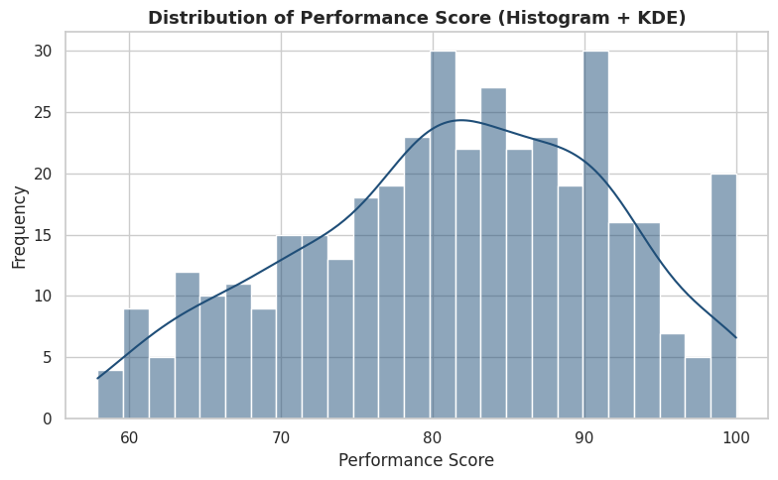
Chart output
Python code:
# 6.2 Boxplot of MonthlySales by Department - shows median, IQR box, whiskers, and outlier points
fig, ax = plt.subplots(figsize=(9, 5))
sns.boxplot(data=df, x="Department", y="MonthlySales", ax=ax, palette="Blues")
ax.set_title("Monthly Sales by Department (Boxplot)")
plt.tight_layout()
plt.show()
Line-by-line breakdown:
- 6.2 Boxplot of MonthlySales by Department - shows median, IQR box, whiskers, and outlier points
- fig, ax = plt.subplots(figsize=(9, 5)) - Creates a new Matplotlib figure and one or more axes to draw a chart on.
- sns.boxplot(data=df, x="Department", y="MonthlySales", ax=ax, palette="Blues") - Draws a seaborn statistical chart from the DataFrame.
- ax.set_title("Monthly Sales by Department (Boxplot)") - Configures or draws on the chart (titles, labels, the plotted series, or reference lines).
- plt.tight_layout() - Adjusts the overall plot layout or renders it to the notebook.
- plt.show() - Adjusts the overall plot layout or renders it to the notebook.
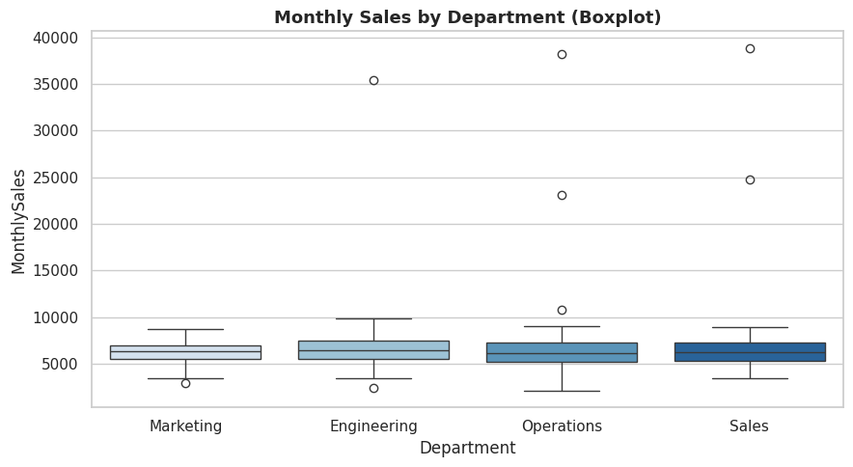
Chart output
Python code:
# 6.3 Violin plot - combines a boxplot with a rotated KDE to show the full distribution shape per group
fig, ax = plt.subplots(figsize=(9, 5))
sns.violinplot(data=df, x="Gender", y="PerformanceScore", ax=ax, palette="Set2")
ax.set_title("Performance Score Distribution by Gender (Violin Plot)")
plt.tight_layout()
plt.show()
Line-by-line breakdown:
- 6.3 Violin plot - combines a boxplot with a rotated KDE to show the full distribution shape per group
- fig, ax = plt.subplots(figsize=(9, 5)) - Creates a new Matplotlib figure and one or more axes to draw a chart on.
- sns.violinplot(data=df, x="Gender", y="PerformanceScore", ax=ax, palette="Set2") - Draws a seaborn statistical chart from the DataFrame.
- ax.set_title("Performance Score Distribution by Gender (Violin Plot)") - Configures or draws on the chart (titles, labels, the plotted series, or reference lines).
- plt.tight_layout() - Adjusts the overall plot layout or renders it to the notebook.
- plt.show() - Adjusts the overall plot layout or renders it to the notebook.
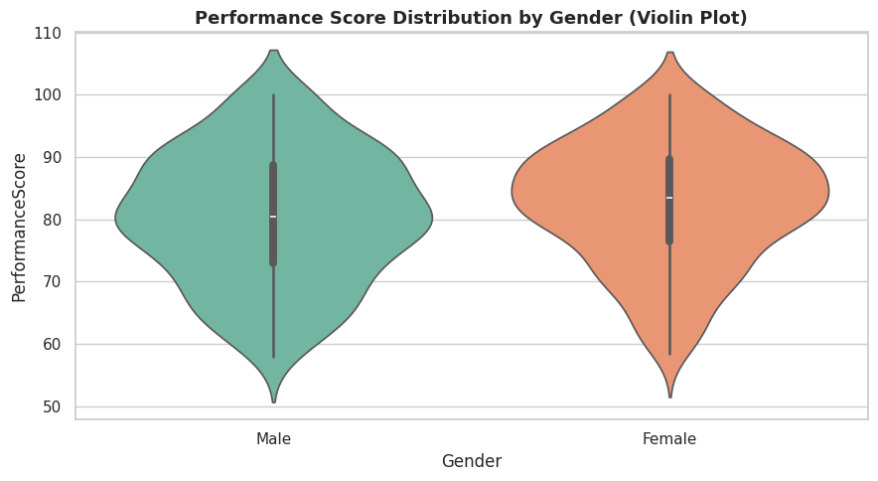
Chart output
Python code:
# 6.4 Scatter plot - relationship between YearsExperience and PerformanceScore
fig, ax = plt.subplots()
sns.scatterplot(data=df, x="YearsExperience", y="PerformanceScore", hue="Department", ax=ax, alpha=0.7)
ax.set_title("Years of Experience vs Performance Score")
plt.tight_layout()
plt.show()
Line-by-line breakdown:
- 6.4 Scatter plot - relationship between YearsExperience and PerformanceScore
- fig, ax = plt.subplots() - Creates a new Matplotlib figure and one or more axes to draw a chart on.
- sns.scatterplot(data=df, x="YearsExperience", y="PerformanceScore", hue="Department", ax=ax, alpha=0.7) - Draws a seaborn statistical chart from the DataFrame.
- ax.set_title("Years of Experience vs Performance Score") - Configures or draws on the chart (titles, labels, the plotted series, or reference lines).
- plt.tight_layout() - Adjusts the overall plot layout or renders it to the notebook.
- plt.show() - Adjusts the overall plot layout or renders it to the notebook.
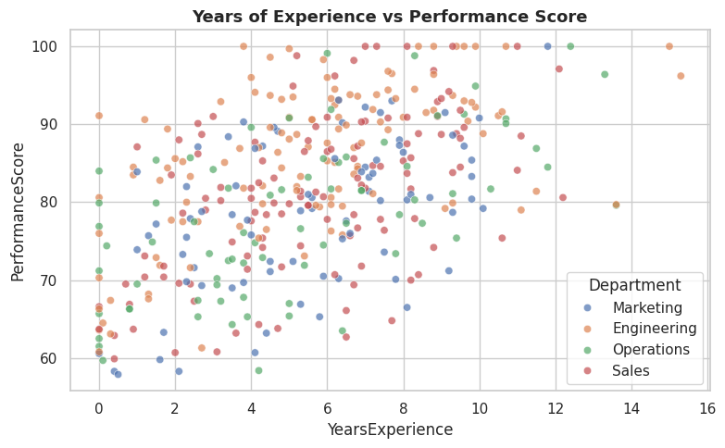
Chart output
Python code:
# 6.5 Pair plot - all pairwise scatter relationships + individual histograms in one grid
pair_cols = ["YearsExperience", "TrainingHours", "PerformanceScore", "MonthlySales"]
sns.pairplot(df[pair_cols + ["Department"]], hue="Department", corner=True, height=2.1)
plt.suptitle("Pairwise Relationships Between Key Numeric Variables", y=1.02)
plt.show()
Line-by-line breakdown:
- 6.5 Pair plot - all pairwise scatter relationships + individual histograms in one grid
- pair_cols = ["YearsExperience", "TrainingHours", "PerformanceScore", "MonthlySales"] - Computes a value and stores it in the variable pair_cols for use in later lines.
- sns.pairplot(df[pair_cols + ["Department"]], hue="Department", corner=True, height=2.1) - Draws a seaborn statistical chart from the DataFrame.
- plt.suptitle("Pairwise Relationships Between Key Numeric Variables", y=1.02) - Adjusts the overall plot layout or renders it to the notebook.
- plt.show() - Adjusts the overall plot layout or renders it to the notebook.
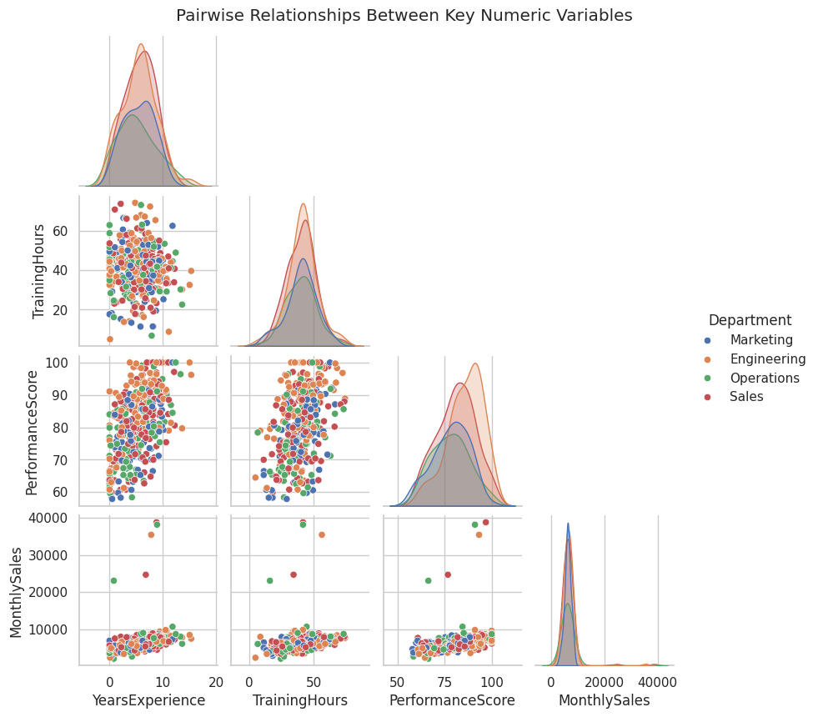
Chart output
Python code:
# 6.6 Correlation heatmap across all numeric columns
corr_matrix = df[numeric_cols].corr(method="pearson")
fig, ax = plt.subplots(figsize=(9, 7))
sns.heatmap(corr_matrix, annot=True, fmt=".2f", cmap="coolwarm", center=0, ax=ax, square=True)
ax.set_title("Pearson Correlation Heatmap")
plt.tight_layout()
plt.show()
Line-by-line breakdown:
- 6.6 Correlation heatmap across all numeric columns
- corr_matrix = df[numeric_cols].corr(method="pearson") - Computes a value and stores it in the variable corr_matrix for use in later lines.
- fig, ax = plt.subplots(figsize=(9, 7)) - Creates a new Matplotlib figure and one or more axes to draw a chart on.
- sns.heatmap(corr_matrix, annot=True, fmt=".2f", cmap="coolwarm", center=0, ax=ax, square=True) - Draws a seaborn statistical chart from the DataFrame.
- ax.set_title("Pearson Correlation Heatmap") - Configures or draws on the chart (titles, labels, the plotted series, or reference lines).
- plt.tight_layout() - Adjusts the overall plot layout or renders it to the notebook.
- plt.show() - Adjusts the overall plot layout or renders it to the notebook.
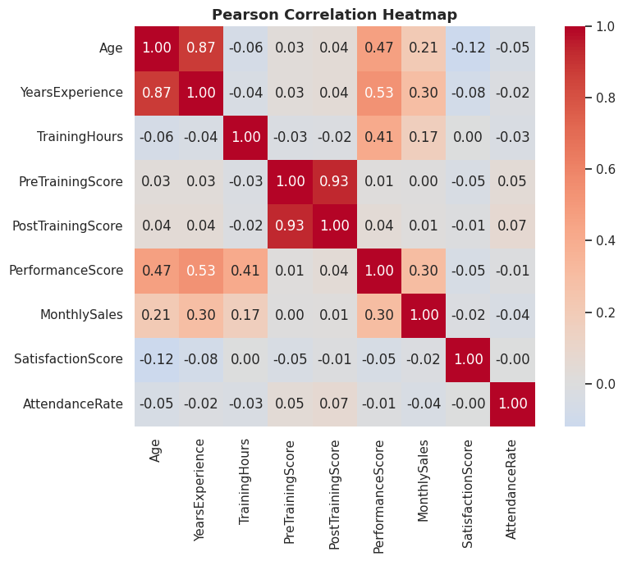
Chart output
Python code:
# 6.7 Q-Q (quantile-quantile) plot - visually checks whether a variable follows a normal distribution.
# Points lying on the diagonal red line indicate approximate normality.
fig, ax = plt.subplots()
stats.probplot(df["PerformanceScore"], dist="norm", plot=ax)
ax.set_title("Q-Q Plot of Performance Score vs Normal Distribution")
plt.tight_layout()
plt.show()
Line-by-line breakdown:
- 6.7 Q-Q (quantile-quantile) plot - visually checks whether a variable follows a normal distribution.
- Points lying on the diagonal red line indicate approximate normality.
- fig, ax = plt.subplots() - Creates a new Matplotlib figure and one or more axes to draw a chart on.
- stats.probplot(df["PerformanceScore"], dist="norm", plot=ax) - Computes a value and stores it in the variable stats.probplot(df["PerformanceScore"], dist for use in later lines.
- ax.set_title("Q-Q Plot of Performance Score vs Normal Distribution") - Configures or draws on the chart (titles, labels, the plotted series, or reference lines).
- plt.tight_layout() - Adjusts the overall plot layout or renders it to the notebook.
- plt.show() - Adjusts the overall plot layout or renders it to the notebook.
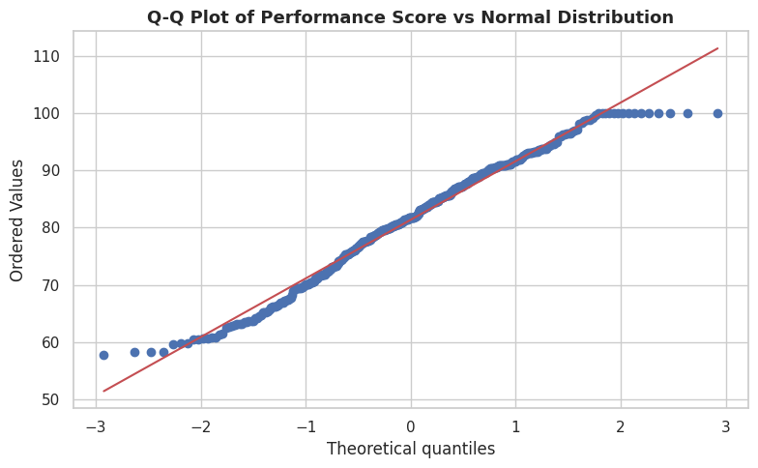
Chart output
Python code:
# 6.8 Bar chart of a categorical variable - counts per Department
fig, ax = plt.subplots()
order = df["Department"].value_counts().index
sns.countplot(data=df, x="Department", order=order, palette="viridis", ax=ax)
ax.set_title("Number of Employees per Department")
for container in ax.containers:
ax.bar_label(container)
plt.tight_layout()
plt.show()
Line-by-line breakdown:
- 6.8 Bar chart of a categorical variable - counts per Department
- fig, ax = plt.subplots() - Creates a new Matplotlib figure and one or more axes to draw a chart on.
- order = df["Department"].value_counts().index - Computes a value and stores it in the variable order for use in later lines.
- sns.countplot(data=df, x="Department", order=order, palette="viridis", ax=ax) - Draws a seaborn statistical chart from the DataFrame.
- ax.set_title("Number of Employees per Department") - Configures or draws on the chart (titles, labels, the plotted series, or reference lines).
- for container in ax.containers: - Loops over a sequence, repeating the indented statements for each item.
- ax.bar_label(container) - Configures or draws on the chart (titles, labels, the plotted series, or reference lines).
- plt.tight_layout() - Adjusts the overall plot layout or renders it to the notebook.
- plt.show() - Adjusts the overall plot layout or renders it to the notebook.
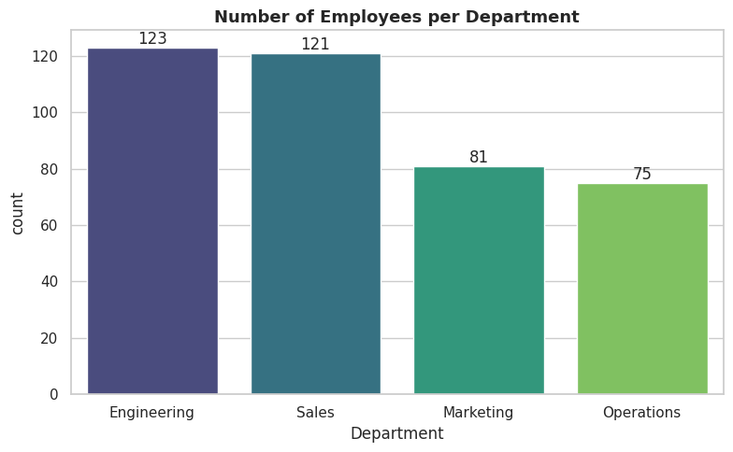
Chart output

7. Probability Distributions
scipy.stats implements every classical distribution with a common interface: .pdf() / .pmf() (density/mass), .cdf() (cumulative probability), .ppf() (inverse CDF / quantile function), and .rvs() (random sampling). We walk through the distributions most used in practice.
Python code:
# 7.1 Normal (Gaussian) distribution - the workhorse continuous distribution
mu, sigma = df["PerformanceScore"].mean(), df["PerformanceScore"].std()
x = np.linspace(mu - 4*sigma, mu + 4*sigma, 400)
pdf_vals = stats.norm.pdf(x, loc=mu, scale=sigma)
fig, ax = plt.subplots()
ax.plot(x, pdf_vals, color="#1F4E78", lw=2)
ax.fill_between(x, pdf_vals, alpha=0.2, color="#1F4E78")
ax.set_title(f"Normal Distribution Fitted to Performance Score (mean={mu:.1f}, sd={sigma:.1f})")
ax.set_xlabel("Performance Score"); ax.set_ylabel("Probability Density")
plt.tight_layout(); plt.show()
# Key normal-distribution probability questions, answered with .cdf() and .ppf()
p_above_90 = 1 - stats.norm.cdf(90, loc=mu, scale=sigma)
p_below_60 = stats.norm.cdf(60, loc=mu, scale=sigma)
score_top_10pct = stats.norm.ppf(0.90, loc=mu, scale=sigma)
print(f"P(PerformanceScore > 90) = {p_above_90:.4f}")
print(f"P(PerformanceScore < 60) = {p_below_60:.4f}")
print(f"Score marking the top 10% = {score_top_10pct:.2f}")
Line-by-line breakdown:
- 7.1 Normal (Gaussian) distribution - the workhorse continuous distribution
- mu, sigma = df["PerformanceScore"].mean(), df["PerformanceScore"].std() - Computes a value and stores it in the variable mu, sigma for use in later lines.
- x = np.linspace(mu - 4*sigma, mu + 4*sigma, 400) - Computes a value and stores it in the variable x for use in later lines.
- pdf_vals = stats.norm.pdf(x, loc=mu, scale=sigma) - Computes a value and stores it in the variable pdf_vals for use in later lines.
- fig, ax = plt.subplots() - Creates a new Matplotlib figure and one or more axes to draw a chart on.
- ax.plot(x, pdf_vals, color="#1F4E78", lw=2) - Configures or draws on the chart (titles, labels, the plotted series, or reference lines).
- ax.fill_between(x, pdf_vals, alpha=0.2, color="#1F4E78") - Configures or draws on the chart (titles, labels, the plotted series, or reference lines).
- ax.set_title(f"Normal Distribution Fitted to Performance Score (mean={mu:.1f}, sd={sigma:.1f})") - Configures or draws on the chart (titles, labels, the plotted series, or reference lines).
- ax.set_xlabel("Performance Score"); ax.set_ylabel("Probability Density") - Configures or draws on the chart (titles, labels, the plotted series, or reference lines).
- plt.tight_layout(); plt.show() - Adjusts the overall plot layout or renders it to the notebook.
- Key normal-distribution probability questions, answered with .cdf() and .ppf()
- p_above_90 = 1 - stats.norm.cdf(90, loc=mu, scale=sigma) - Computes a value and stores it in the variable p_above_90 for use in later lines.
- p_below_60 = stats.norm.cdf(60, loc=mu, scale=sigma) - Computes a value and stores it in the variable p_below_60 for use in later lines.
- score_top_10pct = stats.norm.ppf(0.90, loc=mu, scale=sigma) - Computes a value and stores it in the variable score_top_10pct for use in later lines.
- print(f"P(PerformanceScore > 90) = {p_above_90:.4f}") - Prints a result to the notebook output so it can be read directly.
- print(f"P(PerformanceScore < 60) = {p_below_60:.4f}") - Prints a result to the notebook output so it can be read directly.
- print(f"Score marking the top 10% = {score_top_10pct:.2f}") - Prints a result to the notebook output so it can be read directly.
Output:
P(PerformanceScore > 90) = 0.2004
P(PerformanceScore < 60) = 0.0186
Score marking the top 10% = 94.53
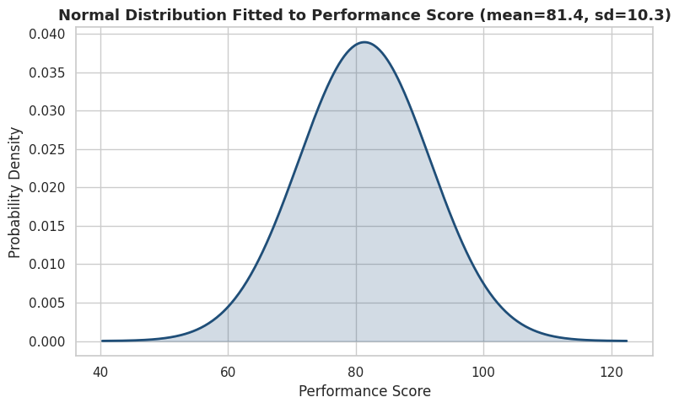
Chart output
Python code:
# 7.2 Binomial distribution - number of successes in n independent yes/no trials
# Example: probability of exactly k promotions out of 20 employees, given the sample promotion rate
n_trials = 20
p_success = df["Promoted"].mean()
k = np.arange(0, n_trials + 1)
pmf_vals = stats.binom.pmf(k, n=n_trials, p=p_success)
fig, ax = plt.subplots()
ax.bar(k, pmf_vals, color="#2E75B6")
ax.set_title(f"Binomial(n={n_trials}, p={p_success:.2f}) - Number of Promotions")
ax.set_xlabel("Number Promoted"); ax.set_ylabel("Probability")
plt.tight_layout(); plt.show()
print(f"P(exactly 5 promoted out of 20) = {stats.binom.pmf(5, n_trials, p_success):.4f}")
print(f"P(at most 3 promoted out of 20) = {stats.binom.cdf(3, n_trials, p_success):.4f}")
print(f"P(more than 8 promoted out of 20) = {1 - stats.binom.cdf(8, n_trials, p_success):.4f}")
Line-by-line breakdown:
- 7.2 Binomial distribution - number of successes in n independent yes/no trials
- Example: probability of exactly k promotions out of 20 employees, given the sample promotion rate
- n_trials = 20 - Computes a value and stores it in the variable n_trials for use in later lines.
- p_success = df["Promoted"].mean() - Computes a value and stores it in the variable p_success for use in later lines.
- k = np.arange(0, n_trials + 1) - Computes a value and stores it in the variable k for use in later lines.
- pmf_vals = stats.binom.pmf(k, n=n_trials, p=p_success) - Computes a value and stores it in the variable pmf_vals for use in later lines.
- fig, ax = plt.subplots() - Creates a new Matplotlib figure and one or more axes to draw a chart on.
- ax.bar(k, pmf_vals, color="#2E75B6") - Configures or draws on the chart (titles, labels, the plotted series, or reference lines).
- ax.set_title(f"Binomial(n={n_trials}, p={p_success:.2f}) - Number of Promotions") - Configures or draws on the chart (titles, labels, the plotted series, or reference lines).
- ax.set_xlabel("Number Promoted"); ax.set_ylabel("Probability") - Configures or draws on the chart (titles, labels, the plotted series, or reference lines).
- plt.tight_layout(); plt.show() - Adjusts the overall plot layout or renders it to the notebook.
- print(f"P(exactly 5 promoted out of 20) = {stats.binom.pmf(5, n_trials, p_success):.4f}") - Prints a result to the notebook output so it can be read directly.
- print(f"P(at most 3 promoted out of 20) = {stats.binom.cdf(3, n_trials, p_success):.4f}") - Prints a result to the notebook output so it can be read directly.
- print(f"P(more than 8 promoted out of 20) = {1 - stats.binom.cdf(8, n_trials, p_success):.4f}") - Prints a result to the notebook output so it can be read directly.
Output:
P(exactly 5 promoted out of 20) = 0.0005
P(at most 3 promoted out of 20) = 0.0000
P(more than 8 promoted out of 20) = 0.9692
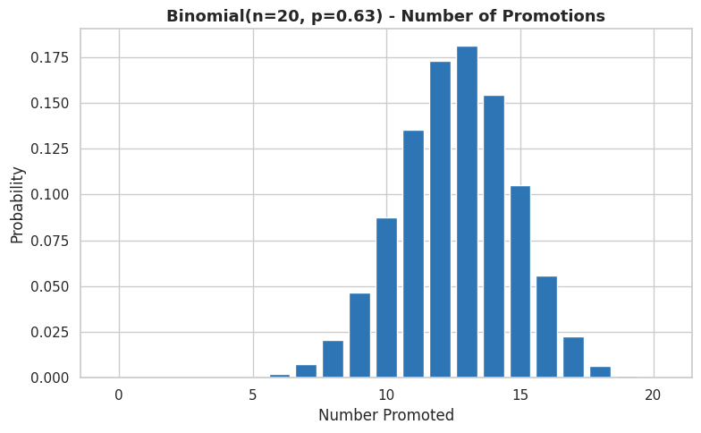
Chart output
Python code:
# 7.3 Poisson distribution - models counts of rare events in a fixed interval
# Example: number of promotions per 20-employee batch, modelled as a Poisson process
lam = n_trials * p_success # expected count (lambda) matches the binomial mean above
k = np.arange(0, 15)
pmf_vals = stats.poisson.pmf(k, mu=lam)
fig, ax = plt.subplots()
ax.bar(k, pmf_vals, color="#548235")
ax.set_title(f"Poisson(lambda={lam:.2f}) Approximation of Promotion Counts")
ax.set_xlabel("Count"); ax.set_ylabel("Probability")
plt.tight_layout(); plt.show()
Line-by-line breakdown:
- 7.3 Poisson distribution - models counts of rare events in a fixed interval
- Example: number of promotions per 20-employee batch, modelled as a Poisson process
- lam = n_trials * p_success - expected count (lambda) matches the binomial mean above
- k = np.arange(0, 15) - Computes a value and stores it in the variable k for use in later lines.
- pmf_vals = stats.poisson.pmf(k, mu=lam) - Computes a value and stores it in the variable pmf_vals for use in later lines.
- fig, ax = plt.subplots() - Creates a new Matplotlib figure and one or more axes to draw a chart on.
- ax.bar(k, pmf_vals, color="#548235") - Configures or draws on the chart (titles, labels, the plotted series, or reference lines).
- ax.set_title(f"Poisson(lambda={lam:.2f}) Approximation of Promotion Counts") - Configures or draws on the chart (titles, labels, the plotted series, or reference lines).
- ax.set_xlabel("Count"); ax.set_ylabel("Probability") - Configures or draws on the chart (titles, labels, the plotted series, or reference lines).
- plt.tight_layout(); plt.show() - Adjusts the overall plot layout or renders it to the notebook.
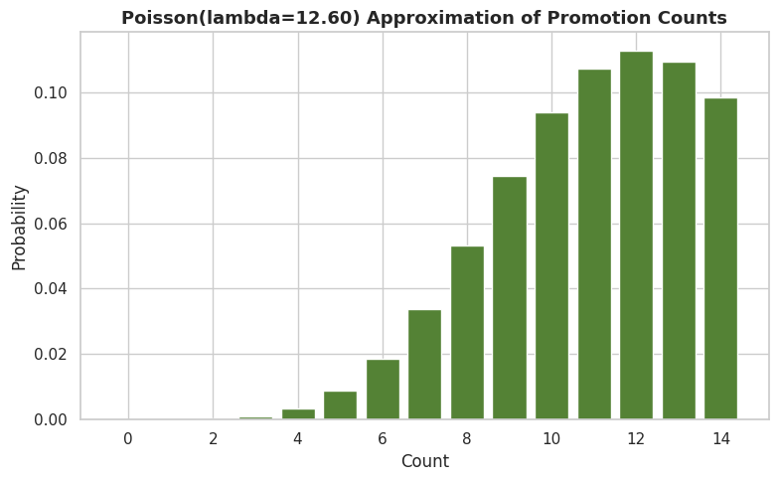
Chart output
Python code:
# 7.4 Uniform distribution - every value in [a, b] is equally likely
a, b = 0, 10
x = np.linspace(a - 1, b + 1, 200)
fig, ax = plt.subplots()
ax.plot(x, stats.uniform.pdf(x, loc=a, scale=b - a), color="#BF8F00", lw=2)
ax.set_title(f"Uniform Distribution on [{a}, {b}]")
plt.tight_layout(); plt.show()
Line-by-line breakdown:
- 7.4 Uniform distribution - every value in [a, b] is equally likely
- a, b = 0, 10 - Computes a value and stores it in the variable a, b for use in later lines.
- x = np.linspace(a - 1, b + 1, 200) - Computes a value and stores it in the variable x for use in later lines.
- fig, ax = plt.subplots() - Creates a new Matplotlib figure and one or more axes to draw a chart on.
- ax.plot(x, stats.uniform.pdf(x, loc=a, scale=b - a), color="#BF8F00", lw=2) - Configures or draws on the chart (titles, labels, the plotted series, or reference lines).
- ax.set_title(f"Uniform Distribution on [{a}, {b}]") - Configures or draws on the chart (titles, labels, the plotted series, or reference lines).
- plt.tight_layout(); plt.show() - Adjusts the overall plot layout or renders it to the notebook.
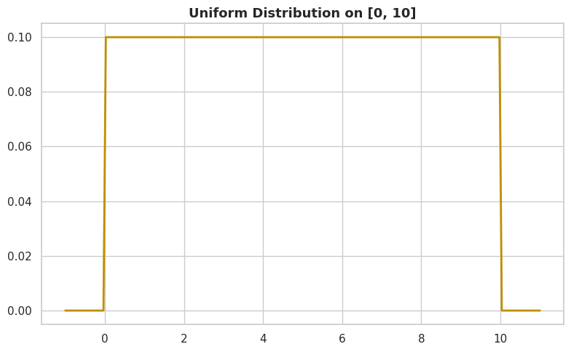
Chart output
Python code:
# 7.5 Exponential distribution - models waiting times between independent events
# Example: time (in months) between successive promotions, assuming a constant promotion rate
rate = 1 / 6 # assume an average of one promotion every 6 months per department
x = np.linspace(0, 30, 200)
fig, ax = plt.subplots()
ax.plot(x, stats.expon.pdf(x, scale=1/rate), color="#C00000", lw=2)
ax.set_title("Exponential Distribution - Time Between Promotions (mean = 6 months)")
ax.set_xlabel("Months"); ax.set_ylabel("Probability Density")
plt.tight_layout(); plt.show()
Line-by-line breakdown:
- 7.5 Exponential distribution - models waiting times between independent events
- Example: time (in months) between successive promotions, assuming a constant promotion rate
- rate = 1 / 6 - assume an average of one promotion every 6 months per department
- x = np.linspace(0, 30, 200) - Computes a value and stores it in the variable x for use in later lines.
- fig, ax = plt.subplots() - Creates a new Matplotlib figure and one or more axes to draw a chart on.
- ax.plot(x, stats.expon.pdf(x, scale=1/rate), color="#C00000", lw=2) - Configures or draws on the chart (titles, labels, the plotted series, or reference lines).
- ax.set_title("Exponential Distribution - Time Between Promotions (mean = 6 months)") - Configures or draws on the chart (titles, labels, the plotted series, or reference lines).
- ax.set_xlabel("Months"); ax.set_ylabel("Probability Density") - Configures or draws on the chart (titles, labels, the plotted series, or reference lines).
- plt.tight_layout(); plt.show() - Adjusts the overall plot layout or renders it to the notebook.
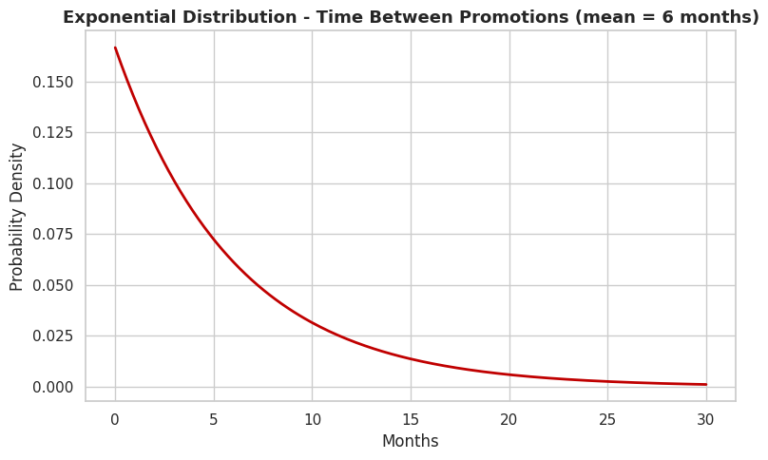
Chart output
Python code:
# 7.6 Fitting a distribution to real data
# stats.norm.fit() returns the maximum-likelihood mean and std that best fit the observed data
fitted_mu, fitted_sigma = stats.norm.fit(df["PerformanceScore"])
print(f"Best-fit Normal parameters for PerformanceScore: mean={fitted_mu:.2f}, sd={fitted_sigma:.2f}")
print(f"(Compare with the sample mean={df['PerformanceScore'].mean():.2f} and sd={df['PerformanceScore'].std():.2f} - "
f"fit() uses the population, ddof=0, convention, which is why the sd differs slightly.)")
Line-by-line breakdown:
- 7.6 Fitting a distribution to real data
- stats.norm.fit() returns the maximum-likelihood mean and std that best fit the observed data
- fitted_mu, fitted_sigma = stats.norm.fit(df["PerformanceScore"]) - Computes a value and stores it in the variable fitted_mu, fitted_sigma for use in later lines.
- print(f"Best-fit Normal parameters for PerformanceScore: mean={fitted_mu:.2f}, sd={fitted_sigma:.2f}") - Prints a result to the notebook output so it can be read directly.
- print(f"(Compare with the sample mean={df['PerformanceScore'].mean():.2f} and sd={df['PerformanceScore'].std():.2f} - " - Prints a result to the notebook output so it can be read directly.
- f"fit() uses the population, ddof=0, convention, which is why the sd differs slightly.)") - Computes a value and stores it in the variable f"fit() uses the population, ddof for use in later lines.
Output:
Best-fit Normal parameters for PerformanceScore: mean=81.38, sd=10.24
(Compare with the sample mean=81.38 and sd=10.26 - fit() uses the population, ddof=0, convention, which is why the sd differs slightly.)

8. Sampling and the Central Limit Theorem (CLT)
The CLT states that the sampling distribution of the mean approaches a Normal distribution as sample size grows - regardless of the shape of the original population. We demonstrate this by repeatedly drawing samples from the (right-skewed) MonthlySales column and plotting the distribution of the sample means.
Python code:
population = df["MonthlySales"].values
sample_size = 30
n_samples = 2000
sample_means = [RNG.choice(population, size=sample_size, replace=True).mean() for _ in range(n_samples)]
fig, axes = plt.subplots(1, 2, figsize=(13, 4.5))
sns.histplot(population, kde=True, ax=axes[0], color="#C00000", bins=30)
axes[0].set_title("Original Population Distribution\n(MonthlySales - right-skewed)")
sns.histplot(sample_means, kde=True, ax=axes[1], color="#1F4E78", bins=30)
axes[1].set_title(f"Distribution of {n_samples} Sample Means\n(sample size n={sample_size} - looks Normal)")
plt.tight_layout(); plt.show()
print(f"Population mean: {population.mean():.2f} | Mean of sample means: {np.mean(sample_means):.2f}")
print(f"Population std: {population.std():.2f} | Std of sample means (standard error): {np.std(sample_means):.2f}")
print(f"Theoretical standard error (population_std / sqrt(n)): {population.std()/np.sqrt(sample_size):.2f}")
Line-by-line breakdown:
- population = df["MonthlySales"].values - Computes a value and stores it in the variable population for use in later lines.
- sample_size = 30 - Computes a value and stores it in the variable sample_size for use in later lines.
- n_samples = 2000 - Computes a value and stores it in the variable n_samples for use in later lines.
- sample_means = [RNG.choice(population, size=sample_size, replace=True).mean() for _ in range(n_samples)] - Computes a value and stores it in the variable sample_means for use in later lines.
- fig, axes = plt.subplots(1, 2, figsize=(13, 4.5)) - Creates a new Matplotlib figure and one or more axes to draw a chart on.
- sns.histplot(population, kde=True, ax=axes[0], color="#C00000", bins=30) - Draws a seaborn statistical chart from the DataFrame.
- axes[0].set_title("Original Population Distribution\n(MonthlySales - right-skewed)") - Configures or draws on the chart (titles, labels, the plotted series, or reference lines).
- sns.histplot(sample_means, kde=True, ax=axes[1], color="#1F4E78", bins=30) - Draws a seaborn statistical chart from the DataFrame.
- axes[1].set_title(f"Distribution of {n_samples} Sample Means\n(sample size n={sample_size} - looks Normal)") - Configures or draws on the chart (titles, labels, the plotted series, or reference lines).
- plt.tight_layout(); plt.show() - Adjusts the overall plot layout or renders it to the notebook.
- print(f"Population mean: {population.mean():.2f} | Mean of sample means: {np.mean(sample_means):.2f}") - Prints a result to the notebook output so it can be read directly.
- print(f"Population std: {population.std():.2f} | Std of sample means (standard error): {np.std(sample_means):.2f}") - Prints a result to the notebook output so it can be read directly.
- print(f"Theoretical standard error (population_std / sqrt(n)): {population.std()/np.sqrt(sample_size):.2f}") - Prints a result to the notebook output so it can be read directly.
Output:
Population mean: 6587.51 | Mean of sample means: 6618.20
Population std: 3252.20 | Std of sample means (standard error): 626.14
Theoretical standard error (population_std / sqrt(n)): 593.77
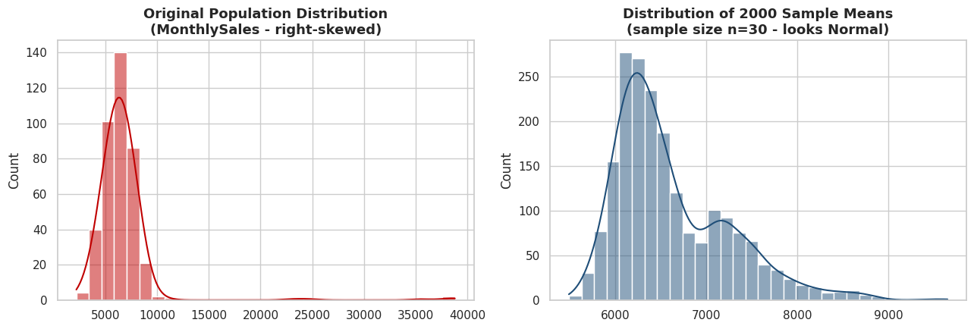
Chart output

9. Confidence Intervals
A confidence interval (CI) gives a range of plausible values for a population parameter. A 95% CI means: if we repeated the sampling process many times, 95% of the intervals constructed this way would contain the true population value.
Python code:
# 9.1 Confidence interval for a mean, using the t-distribution (appropriate when population sd is unknown)
sample = df["PerformanceScore"].dropna()
n = len(sample)
mean = sample.mean()
sem = stats.sem(sample) # standard error of the mean
ci_95 = stats.t.interval(confidence=0.95, df=n - 1, loc=mean, scale=sem)
print(f"Sample mean Performance Score: {mean:.2f}")
print(f"95% Confidence Interval (t-distribution): ({ci_95[0]:.2f}, {ci_95[1]:.2f})")
print("Interpretation: we are 95% confident the true population mean performance score lies in this range.")
Line-by-line breakdown:
- 9.1 Confidence interval for a mean, using the t-distribution (appropriate when population sd is unknown)
- sample = df["PerformanceScore"].dropna() - Computes a value and stores it in the variable sample for use in later lines.
- n = len(sample) - Computes a value and stores it in the variable n for use in later lines.
- mean = sample.mean() - Computes a value and stores it in the variable mean for use in later lines.
- sem = stats.sem(sample) - standard error of the mean
- ci_95 = stats.t.interval(confidence=0.95, df=n - 1, loc=mean, scale=sem) - Computes a value and stores it in the variable ci_95 for use in later lines.
- print(f"Sample mean Performance Score: {mean:.2f}") - Prints a result to the notebook output so it can be read directly.
- print(f"95% Confidence Interval (t-distribution): ({ci_95[0]:.2f}, {ci_95[1]:.2f})") - Prints a result to the notebook output so it can be read directly.
- print("Interpretation: we are 95% confident the true population mean performance score lies in this range.") - Prints a result to the notebook output so it can be read directly.
Output:
Sample mean Performance Score: 81.38
95% Confidence Interval (t-distribution): (80.37, 82.39)
Interpretation: we are 95% confident the true population mean performance score lies in this range.
Python code:
# 9.2 Confidence interval for a proportion (e.g. the promotion rate)
count_promoted = df["Promoted"].sum()
n_total = len(df)
p_hat = count_promoted / n_total
# Normal-approximation (Wald) confidence interval for a proportion
z_critical = stats.norm.ppf(0.975) # z for 95% two-sided CI
se_prop = np.sqrt(p_hat * (1 - p_hat) / n_total)
ci_lower = p_hat - z_critical * se_prop
ci_upper = p_hat + z_critical * se_prop
print(f"Sample promotion rate: {p_hat:.3f} ({count_promoted} of {n_total})")
print(f"95% Confidence Interval for the promotion rate: ({ci_lower:.3f}, {ci_upper:.3f})")
Line-by-line breakdown:
- 9.2 Confidence interval for a proportion (e.g. the promotion rate)
- count_promoted = df["Promoted"].sum() - Computes a value and stores it in the variable count_promoted for use in later lines.
- n_total = len(df) - Computes a value and stores it in the variable n_total for use in later lines.
- p_hat = count_promoted / n_total - Computes a value and stores it in the variable p_hat for use in later lines.
- Normal-approximation (Wald) confidence interval for a proportion
- z_critical = stats.norm.ppf(0.975) - z for 95% two-sided CI
- se_prop = np.sqrt(p_hat * (1 - p_hat) / n_total) - Computes a value and stores it in the variable se_prop for use in later lines.
- ci_lower = p_hat - z_critical * se_prop - Computes a value and stores it in the variable ci_lower for use in later lines.
- ci_upper = p_hat + z_critical * se_prop - Computes a value and stores it in the variable ci_upper for use in later lines.
- print(f"Sample promotion rate: {p_hat:.3f} ({count_promoted} of {n_total})") - Prints a result to the notebook output so it can be read directly.
- print(f"95% Confidence Interval for the promotion rate: ({ci_lower:.3f}, {ci_upper:.3f})") - Prints a result to the notebook output so it can be read directly.
Output:
Sample promotion rate: 0.630 (252 of 400)
95% Confidence Interval for the promotion rate: (0.583, 0.677)

10. Hypothesis Testing - One-Sample and Two-Sample Tests
Every hypothesis test in this notebook follows the same five-step logic:
- State H0 (null hypothesis) and H1 (alternative hypothesis).
- Choose a significance level, alpha (we use 0.05 throughout).
- Compute the test statistic and p-value.
- Compare the p-value to alpha.
- Conclude: reject H0 if p < alpha, otherwise fail to reject H0.
Python code:
# 10.1 One-sample t-test
# H0: the mean PerformanceScore in our data equals 78 (a hypothesised company benchmark)
# H1: the mean PerformanceScore differs from 78
benchmark = 78
t_stat, p_value = stats.ttest_1samp(df["PerformanceScore"], popmean=benchmark)
print(f"One-sample t-test against benchmark = {benchmark}")
print(f"t-statistic = {t_stat:.3f}, p-value = {p_value:.5f}")
print("Conclusion:", "Reject H0 - mean differs from benchmark." if p_value < 0.05
else "Fail to reject H0 - no significant difference from benchmark.")
Line-by-line breakdown:
- 10.1 One-sample t-test
- H0: the mean PerformanceScore in our data equals 78 (a hypothesised company benchmark)
- H1: the mean PerformanceScore differs from 78
- benchmark = 78 - Computes a value and stores it in the variable benchmark for use in later lines.
- t_stat, p_value = stats.ttest_1samp(df["PerformanceScore"], popmean=benchmark) - Computes a value and stores it in the variable t_stat, p_value for use in later lines.
- print(f"One-sample t-test against benchmark = {benchmark}") - Prints a result to the notebook output so it can be read directly.
- print(f"t-statistic = {t_stat:.3f}, p-value = {p_value:.5f}") - Prints a result to the notebook output so it can be read directly.
- print("Conclusion:", "Reject H0 - mean differs from benchmark." if p_value < 0.05 - Prints a result to the notebook output so it can be read directly.
- else "Fail to reject H0 - no significant difference from benchmark.") - Executes this statement as part of the step described above.
Output:
One-sample t-test against benchmark = 78
t-statistic = 6.594, p-value = 0.00000
Conclusion: Reject H0 - mean differs from benchmark.
Python code:
# 10.2 Independent two-sample t-test
# H0: mean PerformanceScore is equal for Male and Female employees
# H1: mean PerformanceScore differs between Male and Female employees
male_scores = df.loc[df["Gender"] == "Male", "PerformanceScore"]
female_scores = df.loc[df["Gender"] == "Female", "PerformanceScore"]
# Levene's test first checks the equal-variance assumption (see Section 14) so we know which
# t-test variant to use.
levene_stat, levene_p = stats.levene(male_scores, female_scores)
equal_var_ok = levene_p > 0.05
t_stat, p_value = stats.ttest_ind(male_scores, female_scores, equal_var=equal_var_ok)
print(f"Levene's test p-value = {levene_p:.4f} -> equal variances assumed: {equal_var_ok}")
print(f"Independent two-sample t-test (Male vs Female PerformanceScore)")
print(f"Male mean = {male_scores.mean():.2f}, Female mean = {female_scores.mean():.2f}")
print(f"t-statistic = {t_stat:.3f}, p-value = {p_value:.5f}")
print("Conclusion:", "Reject H0 - a significant difference exists between genders." if p_value < 0.05
else "Fail to reject H0 - no significant difference between genders.")
Line-by-line breakdown:
- 10.2 Independent two-sample t-test
- H0: mean PerformanceScore is equal for Male and Female employees
- H1: mean PerformanceScore differs between Male and Female employees
- male_scores = df.loc[df["Gender"] == "Male", "PerformanceScore"] - Computes a value and stores it in the variable male_scores for use in later lines.
- female_scores = df.loc[df["Gender"] == "Female", "PerformanceScore"] - Computes a value and stores it in the variable female_scores for use in later lines.
- Levene’s test first checks the equal-variance assumption (see Section 14) so we know which
- t-test variant to use.
- levene_stat, levene_p = stats.levene(male_scores, female_scores) - Computes a value and stores it in the variable levene_stat, levene_p for use in later lines.
- equal_var_ok = levene_p > 0.05 - Computes a value and stores it in the variable equal_var_ok for use in later lines.
- t_stat, p_value = stats.ttest_ind(male_scores, female_scores, equal_var=equal_var_ok) - Computes a value and stores it in the variable t_stat, p_value for use in later lines.
- print(f"Levene's test p-value = {levene_p:.4f} -> equal variances assumed: {equal_var_ok}") - Prints a result to the notebook output so it can be read directly.
- print(f"Independent two-sample t-test (Male vs Female PerformanceScore)") - Prints a result to the notebook output so it can be read directly.
- print(f"Male mean = {male_scores.mean():.2f}, Female mean = {female_scores.mean():.2f}") - Prints a result to the notebook output so it can be read directly.
- print(f"t-statistic = {t_stat:.3f}, p-value = {p_value:.5f}") - Prints a result to the notebook output so it can be read directly.
- print("Conclusion:", "Reject H0 - a significant difference exists between genders." if p_value < 0.05 - Prints a result to the notebook output so it can be read directly.
- else "Fail to reject H0 - no significant difference between genders.") - Executes this statement as part of the step described above.
Output:
Levene's test p-value = 0.2310 -> equal variances assumed: True
Independent two-sample t-test (Male vs Female PerformanceScore)
Male mean = 80.36, Female mean = 82.53
t-statistic = -2.119, p-value = 0.03471
Conclusion: Reject H0 - a significant difference exists between genders.
Python code:
# 10.3 One-sample Z-test (used when population standard deviation is known or n is large)
# Manual implementation since scipy has no built-in one-sample z-test function
from statsmodels.stats.weightstats import ztest
z_stat, p_value = ztest(df["AttendanceRate"].dropna(), value=90)
print("One-sample Z-test: H0: mean AttendanceRate = 90")
print(f"z-statistic = {z_stat:.3f}, p-value = {p_value:.5f}")
print("Conclusion:", "Reject H0." if p_value < 0.05 else "Fail to reject H0.")
Line-by-line breakdown:
- 10.3 One-sample Z-test (used when population standard deviation is known or n is large)
- Manual implementation since scipy has no built-in one-sample z-test function
- from statsmodels.stats.weightstats import ztest - Imports the library or function needed for the step below.
- z_stat, p_value = ztest(df["AttendanceRate"].dropna(), value=90) - Computes a value and stores it in the variable z_stat, p_value for use in later lines.
- print("One-sample Z-test: H0: mean AttendanceRate = 90") - Prints a result to the notebook output so it can be read directly.
- print(f"z-statistic = {z_stat:.3f}, p-value = {p_value:.5f}") - Prints a result to the notebook output so it can be read directly.
- print("Conclusion:", "Reject H0." if p_value < 0.05 else "Fail to reject H0.") - Prints a result to the notebook output so it can be read directly.
Output:
One-sample Z-test: H0: mean AttendanceRate = 90
z-statistic = 11.630, p-value = 0.00000
Conclusion: Reject H0.

11. Paired-Samples t-Test
Used when the same subjects are measured twice (before/after). Here we test whether training improved scores: PreTrainingScore vs PostTrainingScore for the same employees.
Python code:
# H0: mean difference between Post- and Pre-training scores is 0 (no improvement)
# H1: mean difference is not 0 (training had an effect)
pre = df["PreTrainingScore"]
post = df["PostTrainingScore"]
diff = post - pre
t_stat, p_value = stats.ttest_rel(post, pre)
print(f"Mean Pre-Training Score: {pre.mean():.2f}")
print(f"Mean Post-Training Score: {post.mean():.2f}")
print(f"Mean improvement: {diff.mean():.2f}")
print(f"Paired t-test: t-statistic = {t_stat:.3f}, p-value = {p_value:.6f}")
print("Conclusion:", "Reject H0 - training produced a statistically significant improvement."
if p_value < 0.05 else "Fail to reject H0 - no significant improvement detected.")
fig, ax = plt.subplots()
sns.kdeplot(pre, label="Pre-Training", fill=True, ax=ax)
sns.kdeplot(post, label="Post-Training", fill=True, ax=ax)
ax.set_title("Pre- vs Post-Training Score Distributions")
ax.legend()
plt.tight_layout(); plt.show()
Line-by-line breakdown:
- H0: mean difference between Post- and Pre-training scores is 0 (no improvement)
- H1: mean difference is not 0 (training had an effect)
- pre = df["PreTrainingScore"] - Computes a value and stores it in the variable pre for use in later lines.
- post = df["PostTrainingScore"] - Computes a value and stores it in the variable post for use in later lines.
- diff = post - pre - Computes a value and stores it in the variable diff for use in later lines.
- t_stat, p_value = stats.ttest_rel(post, pre) - Computes a value and stores it in the variable t_stat, p_value for use in later lines.
- print(f"Mean Pre-Training Score: {pre.mean():.2f}") - Prints a result to the notebook output so it can be read directly.
- print(f"Mean Post-Training Score: {post.mean():.2f}") - Prints a result to the notebook output so it can be read directly.
- print(f"Mean improvement: {diff.mean():.2f}") - Prints a result to the notebook output so it can be read directly.
- print(f"Paired t-test: t-statistic = {t_stat:.3f}, p-value = {p_value:.6f}") - Prints a result to the notebook output so it can be read directly.
- print("Conclusion:", "Reject H0 - training produced a statistically significant improvement." - Prints a result to the notebook output so it can be read directly.
- if p_value < 0.05 else "Fail to reject H0 - no significant improvement detected.") - Executes this statement as part of the step described above.
- fig, ax = plt.subplots() - Creates a new Matplotlib figure and one or more axes to draw a chart on.
- sns.kdeplot(pre, label="Pre-Training", fill=True, ax=ax) - Draws a seaborn statistical chart from the DataFrame.
- sns.kdeplot(post, label="Post-Training", fill=True, ax=ax) - Draws a seaborn statistical chart from the DataFrame.
- ax.set_title("Pre- vs Post-Training Score Distributions") - Configures or draws on the chart (titles, labels, the plotted series, or reference lines).
- ax.legend() - Configures or draws on the chart (titles, labels, the plotted series, or reference lines).
- plt.tight_layout(); plt.show() - Adjusts the overall plot layout or renders it to the notebook.
Output:
Mean Pre-Training Score: 59.86
Mean Post-Training Score: 67.93
Mean improvement: 8.07
Paired t-test: t-statistic = 41.427, p-value = 0.000000
Conclusion: Reject H0 - training produced a statistically significant improvement.
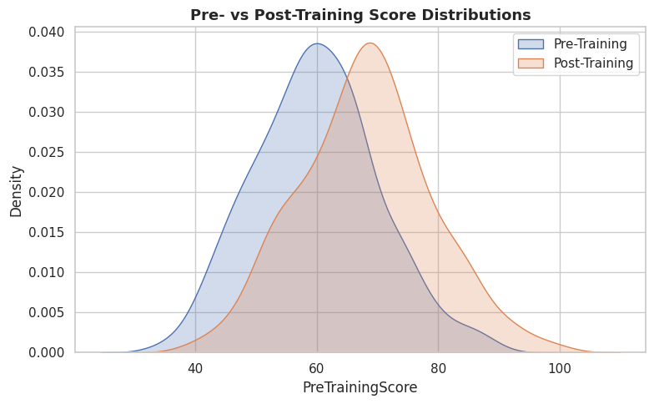
Chart output

12. Analysis of Variance (ANOVA)
ANOVA extends the t-test to three or more groups, testing whether at least one group mean differs from the others.
- One-way ANOVA: one categorical factor (Department) affecting one numeric outcome (PerformanceScore).
- Two-way ANOVA: two categorical factors (Department and Gender) plus their interaction.
- If ANOVA is significant, a post-hoc test (Tukey HSD) identifies which specific pairs of groups differ.
Python code:
# 12.1 One-way ANOVA: does PerformanceScore differ across Departments?
groups = [df.loc[df["Department"] == d, "PerformanceScore"] for d in df["Department"].unique()]
f_stat, p_value = stats.f_oneway(*groups)
print("One-way ANOVA: PerformanceScore ~ Department")
print(f"F-statistic = {f_stat:.3f}, p-value = {p_value:.6f}")
print("Conclusion:", "Reject H0 - at least one department's mean performance differs."
if p_value < 0.05 else "Fail to reject H0 - no significant difference across departments.")
print("\nGroup means:")
print(df.groupby("Department")["PerformanceScore"].mean().round(2))
Line-by-line breakdown:
- 12.1 One-way ANOVA: does PerformanceScore differ across Departments?
- groups = [df.loc[df["Department"] == d, "PerformanceScore"] for d in df["Department"].unique()] - Computes a value and stores it in the variable groups for use in later lines.
- f_stat, p_value = stats.f_oneway(*groups) - Computes a value and stores it in the variable f_stat, p_value for use in later lines.
- print("One-way ANOVA: PerformanceScore ~ Department") - Prints a result to the notebook output so it can be read directly.
- print(f"F-statistic = {f_stat:.3f}, p-value = {p_value:.6f}") - Prints a result to the notebook output so it can be read directly.
- print("Conclusion:", "Reject H0 - at least one department's mean performance differs." - Prints a result to the notebook output so it can be read directly.
- if p_value < 0.05 else "Fail to reject H0 - no significant difference across departments.") - Executes this statement as part of the step described above.
- print("\nGroup means:") - Prints a result to the notebook output so it can be read directly.
- print(df.groupby("Department")["PerformanceScore"].mean().round(2)) - Prints a result to the notebook output so it can be read directly.
Output:
One-way ANOVA: PerformanceScore ~ Department
F-statistic = 14.331, p-value = 0.000000
Conclusion: Reject H0 - at least one department's mean performance differs.
Group means:
Department
Engineering 85.87
Marketing 78.25
Operations 78.08
Sales 80.96
Name: PerformanceScore, dtype: float64
Python code:
# 12.2 Post-hoc Tukey HSD test - pinpoints which specific department pairs differ significantly
from statsmodels.stats.multicomp import pairwise_tukeyhsd
tukey_result = pairwise_tukeyhsd(endog=df["PerformanceScore"], groups=df["Department"], alpha=0.05)
print(tukey_result)
Line-by-line breakdown:
- 12.2 Post-hoc Tukey HSD test - pinpoints which specific department pairs differ significantly
- from statsmodels.stats.multicomp import pairwise_tukeyhsd - Imports the library or function needed for the step below.
- tukey_result = pairwise_tukeyhsd(endog=df["PerformanceScore"], groups=df["Department"], alpha=0.05) - Computes a value and stores it in the variable tukey_result for use in later lines.
- print(tukey_result) - Prints a result to the notebook output so it can be read directly.
Output:
Multiple Comparison of Means - Tukey HSD, FWER=0.05
==============================================================
group1 group2 meandiff p-adj lower upper reject
--------------------------------------------------------------
Engineering Marketing -7.6201 0.0 -11.2304 -4.0098 True
Engineering Operations -7.7907 0.0 -11.4871 -4.0944 True
Engineering Sales -4.9096 0.0006 -8.1401 -1.679 True
Marketing Operations -0.1706 0.9995 -4.2137 3.8725 False
Marketing Sales 2.7105 0.2169 -0.9116 6.3327 False
Operations Sales 2.8812 0.1879 -0.8268 6.5891 False
--------------------------------------------------------------
Python code:
# 12.3 Two-way ANOVA: PerformanceScore ~ Department + Gender + Department:Gender (interaction)
# Built with the statsmodels formula API and an ANOVA (Type II) table
model = smf.ols("PerformanceScore ~ C(Department) + C(Gender) + C(Department):C(Gender)", data=df).fit()
anova_table = sm.stats.anova_lm(model, typ=2)
anova_table
Line-by-line breakdown:
- 12.3 Two-way ANOVA: PerformanceScore ~ Department + Gender + Department:Gender (interaction)
- Built with the statsmodels formula API and an ANOVA (Type II) table
- model = smf.ols("PerformanceScore ~ C(Department) + C(Gender) + C(Department):C(Gender)", data=df).fit() - Computes a value and stores it in the variable model for use in later lines.
- anova_table = sm.stats.anova_lm(model, typ=2) - Computes a value and stores it in the variable anova_table for use in later lines.
- anova_table - Executes this statement as part of the step described above.
Output:
sum_sq df F PR(>F)
C(Department) 4068.396096 3.0 14.286232 7.478953e-09
C(Gender) 425.063960 1.0 4.477855 3.496666e-02
C(Department):C(Gender) 236.146821 3.0 0.829233 4.783718e-01
Residual 37210.913760 392.0 NaN NaN
Reading the two-way ANOVA table: the PR(>F) column is the p-value for each term. A department main effect below 0.05 means departments differ on average; a gender main effect below 0.05 means genders differ on average; a significant interaction term would mean the department effect depends on gender (or vice versa).

13. Non-Parametric Tests
Non-parametric tests make no assumption about the underlying distribution (e.g. normality) and are used when that assumption is violated, or the data is ordinal/ranked.
Parametric test | Non-parametric equivalent
Independent two-sample t-test | Mann-Whitney U test
Paired t-test | Wilcoxon signed-rank test
One-way ANOVA | Kruskal-Wallis H test
Python code:
# 13.1 Mann-Whitney U test - non-parametric alternative to the independent t-test
u_stat, p_value = stats.mannwhitneyu(male_scores, female_scores, alternative="two-sided")
print("Mann-Whitney U test (Male vs Female PerformanceScore)")
print(f"U-statistic = {u_stat:.1f}, p-value = {p_value:.5f}")
print("Conclusion:", "Reject H0." if p_value < 0.05 else "Fail to reject H0.")
Line-by-line breakdown:
- 13.1 Mann-Whitney U test - non-parametric alternative to the independent t-test
- u_stat, p_value = stats.mannwhitneyu(male_scores, female_scores, alternative="two-sided") - Computes a value and stores it in the variable u_stat, p_value for use in later lines.
- print("Mann-Whitney U test (Male vs Female PerformanceScore)") - Prints a result to the notebook output so it can be read directly.
- print(f"U-statistic = {u_stat:.1f}, p-value = {p_value:.5f}") - Prints a result to the notebook output so it can be read directly.
- print("Conclusion:", "Reject H0." if p_value < 0.05 else "Fail to reject H0.") - Prints a result to the notebook output so it can be read directly.
Output:
Mann-Whitney U test (Male vs Female PerformanceScore)
U-statistic = 17417.5, p-value = 0.02963
Conclusion: Reject H0.
Python code:
# 13.2 Wilcoxon signed-rank test - non-parametric alternative to the paired t-test
w_stat, p_value = stats.wilcoxon(post, pre)
print("Wilcoxon signed-rank test (Post vs Pre training scores)")
print(f"W-statistic = {w_stat:.1f}, p-value = {p_value:.6f}")
print("Conclusion:", "Reject H0 - training produced a significant improvement." if p_value < 0.05
else "Fail to reject H0.")
Line-by-line breakdown:
- 13.2 Wilcoxon signed-rank test - non-parametric alternative to the paired t-test
- w_stat, p_value = stats.wilcoxon(post, pre) - Computes a value and stores it in the variable w_stat, p_value for use in later lines.
- print("Wilcoxon signed-rank test (Post vs Pre training scores)") - Prints a result to the notebook output so it can be read directly.
- print(f"W-statistic = {w_stat:.1f}, p-value = {p_value:.6f}") - Prints a result to the notebook output so it can be read directly.
- print("Conclusion:", "Reject H0 - training produced a significant improvement." if p_value < 0.05 - Prints a result to the notebook output so it can be read directly.
- else "Fail to reject H0.") - Executes this statement as part of the step described above.
Output:
Wilcoxon signed-rank test (Post vs Pre training scores)
W-statistic = 97.0, p-value = 0.000000
Conclusion: Reject H0 - training produced a significant improvement.
Python code:
# 13.3 Kruskal-Wallis H test - non-parametric alternative to one-way ANOVA
h_stat, p_value = stats.kruskal(*groups)
print("Kruskal-Wallis H test (PerformanceScore across Departments)")
print(f"H-statistic = {h_stat:.3f}, p-value = {p_value:.6f}")
print("Conclusion:", "Reject H0 - at least one department differs." if p_value < 0.05
else "Fail to reject H0.")
Line-by-line breakdown:
- 13.3 Kruskal-Wallis H test - non-parametric alternative to one-way ANOVA
- h_stat, p_value = stats.kruskal(*groups) - Computes a value and stores it in the variable h_stat, p_value for use in later lines.
- print("Kruskal-Wallis H test (PerformanceScore across Departments)") - Prints a result to the notebook output so it can be read directly.
- print(f"H-statistic = {h_stat:.3f}, p-value = {p_value:.6f}") - Prints a result to the notebook output so it can be read directly.
- print("Conclusion:", "Reject H0 - at least one department differs." if p_value < 0.05 - Prints a result to the notebook output so it can be read directly.
- else "Fail to reject H0.") - Executes this statement as part of the step described above.
Output:
Kruskal-Wallis H test (PerformanceScore across Departments)
H-statistic = 41.098, p-value = 0.000000
Conclusion: Reject H0 - at least one department differs.

14. Tests of Normality and Equal Variance
Many parametric tests (t-tests, ANOVA, Pearson correlation) assume the data is approximately normally distributed and that group variances are roughly equal. We test both assumptions formally.
Python code:
# 14.1 Normality tests on PerformanceScore
shapiro_stat, shapiro_p = stats.shapiro(df["PerformanceScore"])
ks_stat, ks_p = stats.kstest(df["PerformanceScore"], "norm",
args=(df["PerformanceScore"].mean(), df["PerformanceScore"].std()))
dagostino_stat, dagostino_p = stats.normaltest(df["PerformanceScore"])
anderson_result = stats.anderson(df["PerformanceScore"], dist="norm")
print("Normality tests on PerformanceScore (H0: data is normally distributed)")
print(f"Shapiro-Wilk: statistic={shapiro_stat:.4f}, p-value={shapiro_p:.4f}")
print(f"Kolmogorov-Smirnov: statistic={ks_stat:.4f}, p-value={ks_p:.4f}")
print(f"D'Agostino K^2: statistic={dagostino_stat:.4f}, p-value={dagostino_p:.4f}")
print(f"Anderson-Darling: statistic={anderson_result.statistic:.4f} "
f"(critical value at 5% = {anderson_result.critical_values[2]:.4f})")
print()
print("Rule of thumb: with n=400, Shapiro-Wilk is the most reliable of these tests for this sample size.")
Line-by-line breakdown:
- 14.1 Normality tests on PerformanceScore
- shapiro_stat, shapiro_p = stats.shapiro(df["PerformanceScore"]) - Computes a value and stores it in the variable shapiro_stat, shapiro_p for use in later lines.
- ks_stat, ks_p = stats.kstest(df["PerformanceScore"], "norm", - Computes a value and stores it in the variable ks_stat, ks_p for use in later lines.
- args=(df["PerformanceScore"].mean(), df["PerformanceScore"].std())) - Computes a value and stores it in the variable args for use in later lines.
- dagostino_stat, dagostino_p = stats.normaltest(df["PerformanceScore"]) - Computes a value and stores it in the variable dagostino_stat, dagostino_p for use in later lines.
- anderson_result = stats.anderson(df["PerformanceScore"], dist="norm") - Computes a value and stores it in the variable anderson_result for use in later lines.
- print("Normality tests on PerformanceScore (H0: data is normally distributed)") - Prints a result to the notebook output so it can be read directly.
- print(f"Shapiro-Wilk: statistic={shapiro_stat:.4f}, p-value={shapiro_p:.4f}") - Prints a result to the notebook output so it can be read directly.
- print(f"Kolmogorov-Smirnov: statistic={ks_stat:.4f}, p-value={ks_p:.4f}") - Prints a result to the notebook output so it can be read directly.
- print(f"D'Agostino K^2: statistic={dagostino_stat:.4f}, p-value={dagostino_p:.4f}") - Prints a result to the notebook output so it can be read directly.
- print(f"Anderson-Darling: statistic={anderson_result.statistic:.4f} " - Prints a result to the notebook output so it can be read directly.
- f"(critical value at 5% = {anderson_result.critical_values[2]:.4f})") - Computes a value and stores it in the variable f"(critical value at 5% for use in later lines.
- print() - Prints a result to the notebook output so it can be read directly.
- print("Rule of thumb: with n=400, Shapiro-Wilk is the most reliable of these tests for this sample size.") - Prints a result to the notebook output so it can be read directly.
Output:
Normality tests on PerformanceScore (H0: data is normally distributed)
Shapiro-Wilk: statistic=0.9804, p-value=0.0000
Kolmogorov-Smirnov: statistic=0.0422, p-value=0.4621
D'Agostino K^2: statistic=18.1559, p-value=0.0001
Anderson-Darling: statistic=1.5051 (critical value at 5% = 0.7510)
Rule of thumb: with n=400, Shapiro-Wilk is the most reliable of these tests for this sample size.
Python code:
# 14.2 Equal-variance (homogeneity of variance) tests across Departments
levene_stat, levene_p = stats.levene(*groups) # robust to non-normality
bartlett_stat, bartlett_p = stats.bartlett(*groups) # assumes normality, more powerful if met
print("Levene's test (robust): statistic={:.3f}, p-value={:.4f}".format(levene_stat, levene_p))
print("Bartlett's test: statistic={:.3f}, p-value={:.4f}".format(bartlett_stat, bartlett_p))
print("H0 for both: all group variances are equal.")
Line-by-line breakdown:
- 14.2 Equal-variance (homogeneity of variance) tests across Departments
- levene_stat, levene_p = stats.levene(*groups) - robust to non-normality
- bartlett_stat, bartlett_p = stats.bartlett(*groups) - assumes normality, more powerful if met
- print("Levene's test (robust): statistic={:.3f}, p-value={:.4f}".format(levene_stat, levene_p)) - Prints a result to the notebook output so it can be read directly.
- print("Bartlett's test: statistic={:.3f}, p-value={:.4f}".format(bartlett_stat, bartlett_p)) - Prints a result to the notebook output so it can be read directly.
- print("H0 for both: all group variances are equal.") - Prints a result to the notebook output so it can be read directly.
Output:
Levene's test (robust): statistic=0.312, p-value=0.8170
Bartlett's test: statistic=0.655, p-value=0.8837
H0 for both: all group variances are equal.

15. Effect Size
A p-value tells you whether an effect is statistically significant; effect size tells you how large that effect actually is - essential for practical interpretation, especially with big samples where even tiny differences become “significant”.
- Cohen’s d - standardised mean difference, used with t-tests.
- Eta-squared (η²) - proportion of variance explained, used with ANOVA.
Python code:
# 15.1 Cohen's d for the Male vs Female PerformanceScore comparison
def cohens_d(x, y):
nx, ny = len(x), len(y)
pooled_std = np.sqrt(((nx - 1) * x.std(ddof=1)**2 + (ny - 1) * y.std(ddof=1)**2) / (nx + ny - 2))
return (x.mean() - y.mean()) / pooled_std
d = cohens_d(male_scores, female_scores)
print(f"Cohen's d (Male vs Female PerformanceScore) = {d:.3f}")
print("Rule of thumb: 0.2 = small, 0.5 = medium, 0.8 = large effect.")
Line-by-line breakdown:
- 15.1 Cohen’s d for the Male vs Female PerformanceScore comparison
- def cohens_d(x, y): - Defines a reusable function used later in the cell.
- nx, ny = len(x), len(y) - Computes a value and stores it in the variable nx, ny for use in later lines.
- pooled_std = np.sqrt(((nx - 1) * x.std(ddof=1)**2 + (ny - 1) * y.std(ddof=1)**2) / (nx + ny - 2)) - Computes a value and stores it in the variable pooled_std for use in later lines.
- return (x.mean() - y.mean()) / pooled_std - Returns the computed value(s) from the function.
- d = cohens_d(male_scores, female_scores) - Computes a value and stores it in the variable d for use in later lines.
- print(f"Cohen's d (Male vs Female PerformanceScore) = {d:.3f}") - Prints a result to the notebook output so it can be read directly.
- print("Rule of thumb: 0.2 = small, 0.5 = medium, 0.8 = large effect.") - Prints a result to the notebook output so it can be read directly.
Output:
Cohen's d (Male vs Female PerformanceScore) = -0.212
Rule of thumb: 0.2 = small, 0.5 = medium, 0.8 = large effect.
Python code:
# 15.2 Eta-squared for the one-way ANOVA (Department -> PerformanceScore)
grand_mean = df["PerformanceScore"].mean()
ss_between = sum(len(g) * (g.mean() - grand_mean)**2 for g in groups)
ss_total = ((df["PerformanceScore"] - grand_mean)**2).sum()
eta_squared = ss_between / ss_total
print(f"Eta-squared (Department -> PerformanceScore) = {eta_squared:.3f}")
print("Rule of thumb: 0.01 = small, 0.06 = medium, 0.14 = large effect.")
Line-by-line breakdown:
- 15.2 Eta-squared for the one-way ANOVA (Department -> PerformanceScore)
- grand_mean = df["PerformanceScore"].mean() - Computes a value and stores it in the variable grand_mean for use in later lines.
- ss_between = sum(len(g) * (g.mean() - grand_mean)**2 for g in groups) - Computes a value and stores it in the variable ss_between for use in later lines.
- ss_total = ((df["PerformanceScore"] - grand_mean)**2).sum() - Computes a value and stores it in the variable ss_total for use in later lines.
- eta_squared = ss_between / ss_total - Computes a value and stores it in the variable eta_squared for use in later lines.
- print(f"Eta-squared (Department -> PerformanceScore) = {eta_squared:.3f}") - Prints a result to the notebook output so it can be read directly.
- print("Rule of thumb: 0.01 = small, 0.06 = medium, 0.14 = large effect.") - Prints a result to the notebook output so it can be read directly.
Output:
Eta-squared (Department -> PerformanceScore) = 0.098
Rule of thumb: 0.01 = small, 0.06 = medium, 0.14 = large effect.

16. Correlation Analysis
Correlation measures the strength and direction of a relationship between two numeric variables.
- Pearson’s r - linear relationships, assumes roughly normal, continuous data.
- Spearman’s rho - monotonic relationships based on ranks, robust to outliers and non-normal data.
- Kendall’s tau - also rank-based, more robust with small samples or many tied ranks.
Correlation coefficients range from -1 (perfect negative) to +1 (perfect positive); 0 means no linear/monotonic relationship. Correlation does not imply causation.
Python code:
x = df["YearsExperience"]
y = df["PerformanceScore"]
pearson_r, pearson_p = stats.pearsonr(x, y)
spearman_r, spearman_p = stats.spearmanr(x, y)
kendall_tau, kendall_p = stats.kendalltau(x, y)
print("Correlation between YearsExperience and PerformanceScore")
print(f"Pearson's r = {pearson_r:.3f} (p={pearson_p:.5f})")
print(f"Spearman rho = {spearman_r:.3f} (p={spearman_p:.5f})")
print(f"Kendall tau = {kendall_tau:.3f} (p={kendall_p:.5f})")
Line-by-line breakdown:
- x = df["YearsExperience"] - Computes a value and stores it in the variable x for use in later lines.
- y = df["PerformanceScore"] - Computes a value and stores it in the variable y for use in later lines.
- pearson_r, pearson_p = stats.pearsonr(x, y) - Computes a value and stores it in the variable pearson_r, pearson_p for use in later lines.
- spearman_r, spearman_p = stats.spearmanr(x, y) - Computes a value and stores it in the variable spearman_r, spearman_p for use in later lines.
- kendall_tau, kendall_p = stats.kendalltau(x, y) - Computes a value and stores it in the variable kendall_tau, kendall_p for use in later lines.
- print("Correlation between YearsExperience and PerformanceScore") - Prints a result to the notebook output so it can be read directly.
- print(f"Pearson's r = {pearson_r:.3f} (p={pearson_p:.5f})") - Prints a result to the notebook output so it can be read directly.
- print(f"Spearman rho = {spearman_r:.3f} (p={spearman_p:.5f})") - Prints a result to the notebook output so it can be read directly.
- print(f"Kendall tau = {kendall_tau:.3f} (p={kendall_p:.5f})") - Prints a result to the notebook output so it can be read directly.
Output:
Correlation between YearsExperience and PerformanceScore
Pearson's r = 0.532 (p=0.00000)
Spearman rho = 0.517 (p=0.00000)
Kendall tau = 0.361 (p=0.00000)
Python code:
# Full Pearson correlation matrix with a mask hiding the redundant upper triangle
corr = df[numeric_cols].corr()
mask = np.triu(np.ones_like(corr, dtype=bool))
fig, ax = plt.subplots(figsize=(9, 7))
sns.heatmap(corr, mask=mask, annot=True, fmt=".2f", cmap="vlag", center=0, square=True, ax=ax)
ax.set_title("Pearson Correlation Matrix (lower triangle)")
plt.tight_layout(); plt.show()
Line-by-line breakdown:
- Full Pearson correlation matrix with a mask hiding the redundant upper triangle
- corr = df[numeric_cols].corr() - Computes a value and stores it in the variable corr for use in later lines.
- mask = np.triu(np.ones_like(corr, dtype=bool)) - Computes a value and stores it in the variable mask for use in later lines.
- fig, ax = plt.subplots(figsize=(9, 7)) - Creates a new Matplotlib figure and one or more axes to draw a chart on.
- sns.heatmap(corr, mask=mask, annot=True, fmt=".2f", cmap="vlag", center=0, square=True, ax=ax) - Draws a seaborn statistical chart from the DataFrame.
- ax.set_title("Pearson Correlation Matrix (lower triangle)") - Configures or draws on the chart (titles, labels, the plotted series, or reference lines).
- plt.tight_layout(); plt.show() - Adjusts the overall plot layout or renders it to the notebook.
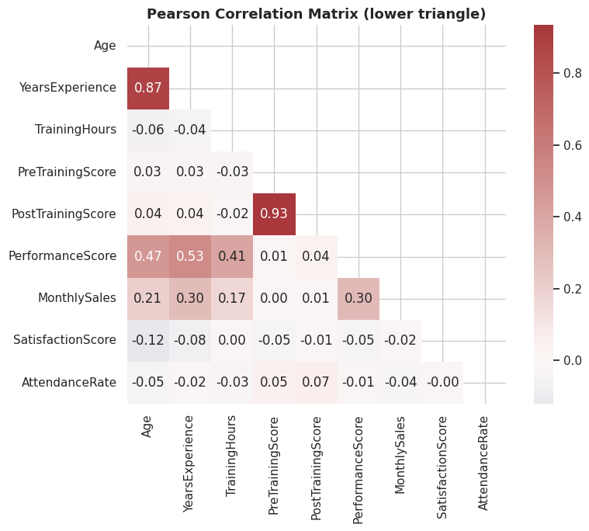
Chart output

17. Chi-Square Tests for Categorical Data
- Chi-square test of independence: are two categorical variables associated?
- Chi-square goodness-of-fit test: does an observed categorical distribution match an expected one?
- Cramer’s V: effect size for the test of independence (0 = no association, 1 = perfect association).
Python code:
# 17.1 Chi-square test of independence: Region vs Promoted
contingency = pd.crosstab(df["Region"], df["Promoted"])
print("Contingency table (observed counts):")
print(contingency)
chi2_stat, p_value, dof, expected = stats.chi2_contingency(contingency)
print(f"\nChi-square statistic = {chi2_stat:.3f}, degrees of freedom = {dof}, p-value = {p_value:.5f}")
print("Conclusion:", "Reject H0 - Region and Promotion status are associated." if p_value < 0.05
else "Fail to reject H0 - no significant association detected.")
# Cramer's V effect size
n = contingency.sum().sum()
min_dim = min(contingency.shape) - 1
cramers_v = np.sqrt(chi2_stat / (n * min_dim))
print(f"Cramer's V (effect size) = {cramers_v:.3f}")
Line-by-line breakdown:
- 17.1 Chi-square test of independence: Region vs Promoted
- contingency = pd.crosstab(df["Region"], df["Promoted"]) - Computes a value and stores it in the variable contingency for use in later lines.
- print("Contingency table (observed counts):") - Prints a result to the notebook output so it can be read directly.
- print(contingency) - Prints a result to the notebook output so it can be read directly.
- chi2_stat, p_value, dof, expected = stats.chi2_contingency(contingency) - Computes a value and stores it in the variable chi2_stat, p_value, dof, expected for use in later lines.
- print(f"\nChi-square statistic = {chi2_stat:.3f}, degrees of freedom = {dof}, p-value = {p_value:.5f}") - Prints a result to the notebook output so it can be read directly.
- print("Conclusion:", "Reject H0 - Region and Promotion status are associated." if p_value < 0.05 - Prints a result to the notebook output so it can be read directly.
- else "Fail to reject H0 - no significant association detected.") - Executes this statement as part of the step described above.
- Cramer’s V effect size
- n = contingency.sum().sum() - Computes a value and stores it in the variable n for use in later lines.
- min_dim = min(contingency.shape) - 1 - Computes a value and stores it in the variable min_dim for use in later lines.
- cramers_v = np.sqrt(chi2_stat / (n * min_dim)) - Computes a value and stores it in the variable cramers_v for use in later lines.
- print(f"Cramer's V (effect size) = {cramers_v:.3f}") - Prints a result to the notebook output so it can be read directly.
Output:
Contingency table (observed counts):
Promoted 0 1
Region
North 57 99
South 49 86
West 42 67
Chi-square statistic = 0.153, degrees of freedom = 2, p-value = 0.92649
Conclusion: Fail to reject H0 - no significant association detected.
Cramer's V (effect size) = 0.020
Python code:
# 17.2 Chi-square goodness-of-fit test: does the observed Education split match an assumed 15/45/30/10 split?
observed_counts = df["Education"].value_counts().reindex(["Diploma", "Bachelors", "Masters", "PhD"]).values
expected_props = np.array([0.15, 0.45, 0.30, 0.10])
expected_counts = expected_props * observed_counts.sum()
chi2_stat, p_value = stats.chisquare(f_obs=observed_counts, f_exp=expected_counts)
print("Observed counts:", dict(zip(["Diploma", "Bachelors", "Masters", "PhD"], observed_counts)))
print("Expected counts:", dict(zip(["Diploma", "Bachelors", "Masters", "PhD"], expected_counts.round(1))))
print(f"\nChi-square statistic = {chi2_stat:.3f}, p-value = {p_value:.5f}")
print("Conclusion:", "Reject H0 - the observed split differs from the assumed split." if p_value < 0.05
else "Fail to reject H0 - observed split is consistent with the assumed split.")
Line-by-line breakdown:
- 17.2 Chi-square goodness-of-fit test: does the observed Education split match an assumed 15/45/30/10 split?
- observed_counts = df["Education"].value_counts().reindex(["Diploma", "Bachelors", "Masters", "PhD"]).values - Computes a value and stores it in the variable observed_counts for use in later lines.
- expected_props = np.array([0.15, 0.45, 0.30, 0.10]) - Computes a value and stores it in the variable expected_props for use in later lines.
- expected_counts = expected_props * observed_counts.sum() - Computes a value and stores it in the variable expected_counts for use in later lines.
- chi2_stat, p_value = stats.chisquare(f_obs=observed_counts, f_exp=expected_counts) - Computes a value and stores it in the variable chi2_stat, p_value for use in later lines.
- print("Observed counts:", dict(zip(["Diploma", "Bachelors", "Masters", "PhD"], observed_counts))) - Prints a result to the notebook output so it can be read directly.
- print("Expected counts:", dict(zip(["Diploma", "Bachelors", "Masters", "PhD"], expected_counts.round(1)))) - Prints a result to the notebook output so it can be read directly.
- print(f"\nChi-square statistic = {chi2_stat:.3f}, p-value = {p_value:.5f}") - Prints a result to the notebook output so it can be read directly.
- print("Conclusion:", "Reject H0 - the observed split differs from the assumed split." if p_value < 0.05 - Prints a result to the notebook output so it can be read directly.
- else "Fail to reject H0 - observed split is consistent with the assumed split.") - Executes this statement as part of the step described above.
Output:
Observed counts: {'Diploma': np.int64(54), 'Bachelors': np.int64(198), 'Masters': np.int64(104), 'PhD': np.int64(44)}
Expected counts: {'Diploma': np.float64(60.0), 'Bachelors': np.float64(180.0), 'Masters': np.float64(120.0), 'PhD': np.float64(40.0)}
Chi-square statistic = 4.933, p-value = 0.17674
Conclusion: Fail to reject H0 - observed split is consistent with the assumed split.

18. Simple and Multiple Linear Regression
Linear regression models a numeric outcome as a linear combination of one or more predictors:
$$y=β_{0}+β_{1}x_{1}+β_{2}x_{2}+…+ε$$
We fit models with statsmodels (for full inferential statistics - coefficients, standard errors, p-values, R²) and cross-check the coefficients with scikit-learn.
Python code:
# 18.1 Simple linear regression: PerformanceScore ~ YearsExperience
simple_model = smf.ols("PerformanceScore ~ YearsExperience", data=df).fit()
print(simple_model.summary())
Line-by-line breakdown:
- 18.1 Simple linear regression: PerformanceScore ~ YearsExperience
- simple_model = smf.ols("PerformanceScore ~ YearsExperience", data=df).fit() - Computes a value and stores it in the variable simple_model for use in later lines.
- print(simple_model.summary()) - Prints a result to the notebook output so it can be read directly.
Output:
OLS Regression Results
==============================================================================
Dep. Variable: PerformanceScore R-squared: 0.283
Model: OLS Adj. R-squared: 0.281
Method: Least Squares F-statistic: 157.1
Date: Fri, 28 Aug 2026 Prob (F-statistic): 1.30e-30
Time: 10:49:16 Log-Likelihood: -1431.7
No. Observations: 400 AIC: 2867.
Df Residuals: 398 BIC: 2875.
Df Model: 1
Covariance Type: nonrobust
===================================================================================
coef std err t P>|t| [0.025 0.975]
-----------------------------------------------------------------------------------
Intercept 71.7558 0.882 81.315 0.000 70.021 73.491
YearsExperience 1.7518 0.140 12.536 0.000 1.477 2.026
==============================================================================
Omnibus: 10.539 Durbin-Watson: 1.957
Prob(Omnibus): 0.005 Jarque-Bera (JB): 6.017
Skew: -0.096 Prob(JB): 0.0494
Kurtosis: 2.431 Cond. No. 13.1
==============================================================================
Notes:
[1] Standard Errors assume that the covariance matrix of
... (output truncated for length) ...
Reading this table, line by line: - coef for YearsExperience - the predicted change in PerformanceScore for each extra year of experience. - P>|t| - p-value for each coefficient; below 0.05 means that predictor is statistically significant. - R-squared - proportion of variance in PerformanceScore explained by YearsExperience alone. - F-statistic / Prob (F-statistic) - tests whether the model as a whole explains significant variance.
Python code:
# Visualise the fitted regression line against the actual data
fig, ax = plt.subplots()
sns.regplot(data=df, x="YearsExperience", y="PerformanceScore",
scatter_kws={"alpha": 0.5}, line_kws={"color": "red"}, ax=ax)
ax.set_title("Simple Linear Regression: PerformanceScore ~ YearsExperience")
plt.tight_layout(); plt.show()
Line-by-line breakdown:
- Visualise the fitted regression line against the actual data
- fig, ax = plt.subplots() - Creates a new Matplotlib figure and one or more axes to draw a chart on.
- sns.regplot(data=df, x="YearsExperience", y="PerformanceScore", - Draws a seaborn statistical chart from the DataFrame.
- scatter_kws={"alpha": 0.5}, line_kws={"color": "red"}, ax=ax) - Computes a value and stores it in the variable scatter_kws for use in later lines.
- ax.set_title("Simple Linear Regression: PerformanceScore ~ YearsExperience") - Configures or draws on the chart (titles, labels, the plotted series, or reference lines).
- plt.tight_layout(); plt.show() - Adjusts the overall plot layout or renders it to the notebook.
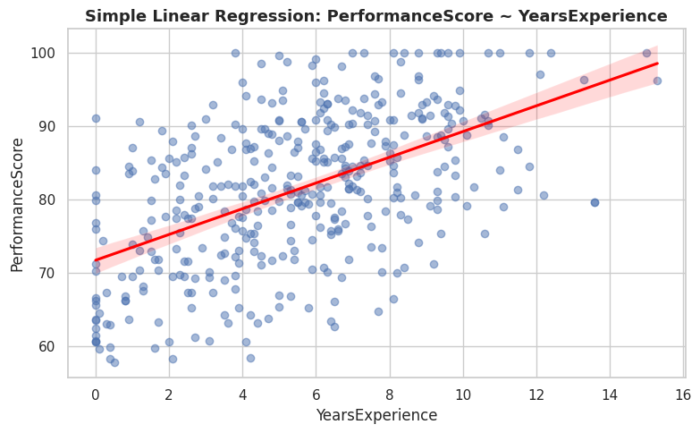
Chart output
Python code:
# 18.2 Multiple linear regression: PerformanceScore ~ YearsExperience + TrainingHours + AttendanceRate + C(Department)
multi_model = smf.ols(
"PerformanceScore ~ YearsExperience + TrainingHours + AttendanceRate + C(Department)",
data=df
).fit()
print(multi_model.summary())
Line-by-line breakdown:
- 18.2 Multiple linear regression: PerformanceScore ~ YearsExperience + TrainingHours + AttendanceRate + C(Department)
- multi_model = smf.ols( - Computes a value and stores it in the variable multi_model for use in later lines.
- "PerformanceScore ~ YearsExperience + TrainingHours + AttendanceRate + C(Department)", - Executes this statement as part of the step described above.
- data=df - Computes a value and stores it in the variable data for use in later lines.
- ).fit() - Executes this statement as part of the step described above.
- print(multi_model.summary()) - Prints a result to the notebook output so it can be read directly.
Output:
OLS Regression Results
==============================================================================
Dep. Variable: PerformanceScore R-squared: 0.552
Model: OLS Adj. R-squared: 0.545
Method: Least Squares F-statistic: 80.57
Date: Fri, 28 Aug 2026 Prob (F-statistic): 2.17e-65
Time: 10:49:16 Log-Likelihood: -1337.9
No. Observations: 400 AIC: 2690.
Df Residuals: 393 BIC: 2718.
Df Model: 6
Covariance Type: nonrobust
===============================================================================================
coef std err t P>|t| [0.025 0.975]
-----------------------------------------------------------------------------------------------
Intercept 53.4637 7.196 7.430 0.000 39.316 67.611
C(Department)[T.Marketing] -7.2021 0.994 -7.244 0.000 -9.157 -5.248
C(Department)[T.Operations] -6.7383 1.016 -6.633 0.000 -8.736 -4.741
C(Department)[T.Sales] -4.9740 0.890 -5.590 0.000 -6.723 -3.225
YearsExperience 1.7915 0.112 16.055 0.000 1.572 2.011
TrainingHours 0.3717 0.030 12.547 0.000 0.313 0.430
AttendanceRate 0.0780 0.076 1.029 0.304 -0.071 0.227
... (output truncated for length) ...
Python code:
# 18.3 Cross-checking coefficients with scikit-learn's LinearRegression
X = df[["YearsExperience", "TrainingHours", "AttendanceRate"]]
y = df["PerformanceScore"]
X_train, X_test, y_train, y_test = train_test_split(X, y, test_size=0.2, random_state=42)
sk_model = LinearRegression()
sk_model.fit(X_train, y_train)
y_pred = sk_model.predict(X_test)
print("scikit-learn coefficients:")
for name, coef in zip(X.columns, sk_model.coef_):
print(f" {name}: {coef:.4f}")
print(f" Intercept: {sk_model.intercept_:.4f}")
print(f"\nTest-set R-squared: {r2_score(y_test, y_pred):.4f}")
print(f"Test-set RMSE: {np.sqrt(mean_squared_error(y_test, y_pred)):.4f}")
Line-by-line breakdown:
- 18.3 Cross-checking coefficients with scikit-learn’s LinearRegression
- X = df[["YearsExperience", "TrainingHours", "AttendanceRate"]] - Computes a value and stores it in the variable X for use in later lines.
- y = df["PerformanceScore"] - Computes a value and stores it in the variable y for use in later lines.
- X_train, X_test, y_train, y_test = train_test_split(X, y, test_size=0.2, random_state=42) - Computes a value and stores it in the variable X_train, X_test, y_train, y_test for use in later lines.
- sk_model = LinearRegression() - Computes a value and stores it in the variable sk_model for use in later lines.
- sk_model.fit(X_train, y_train) - Executes this statement as part of the step described above.
- y_pred = sk_model.predict(X_test) - Computes a value and stores it in the variable y_pred for use in later lines.
- print("scikit-learn coefficients:") - Prints a result to the notebook output so it can be read directly.
- for name, coef in zip(X.columns, sk_model.coef_): - Loops over a sequence, repeating the indented statements for each item.
- print(f" {name}: {coef:.4f}") - Prints a result to the notebook output so it can be read directly.
- print(f" Intercept: {sk_model.intercept_:.4f}") - Prints a result to the notebook output so it can be read directly.
- print(f"\nTest-set R-squared: {r2_score(y_test, y_pred):.4f}") - Prints a result to the notebook output so it can be read directly.
- print(f"Test-set RMSE: {np.sqrt(mean_squared_error(y_test, y_pred)):.4f}") - Prints a result to the notebook output so it can be read directly.
Output:
scikit-learn coefficients:
YearsExperience: 1.7649
TrainingHours: 0.4160
AttendanceRate: -0.0246
Intercept: 57.1214
Test-set R-squared: 0.4389
Test-set RMSE: 7.9297

19. Regression Diagnostics and Multicollinearity
A regression model is only as trustworthy as its assumptions:
- Linearity - checked visually via residual plots.
- Homoscedasticity (constant residual variance) - checked via a residuals-vs-fitted plot and the Breusch-Pagan test.
- Normality of residuals - checked via a Q-Q plot of residuals.
- No severe multicollinearity - checked via the Variance Inflation Factor (VIF); VIF > 10 signals a problem.
Python code:
fitted_vals = multi_model.fittedvalues
residuals = multi_model.resid
fig, axes = plt.subplots(1, 3, figsize=(16, 4.5))
# 19.1 Residuals vs Fitted - should show a random cloud around zero (no pattern = good)
axes[0].scatter(fitted_vals, residuals, alpha=0.5, color="#1F4E78")
axes[0].axhline(0, color="red", linestyle="--")
axes[0].set_xlabel("Fitted values"); axes[0].set_ylabel("Residuals")
axes[0].set_title("Residuals vs Fitted")
# 19.2 Q-Q plot of residuals - checks normality of residuals
stats.probplot(residuals, dist="norm", plot=axes[1])
axes[1].set_title("Q-Q Plot of Residuals")
# 19.3 Histogram of residuals
sns.histplot(residuals, kde=True, ax=axes[2], color="#548235")
axes[2].set_title("Distribution of Residuals")
plt.tight_layout(); plt.show()
Line-by-line breakdown:
- fitted_vals = multi_model.fittedvalues - Computes a value and stores it in the variable fitted_vals for use in later lines.
- residuals = multi_model.resid - Computes a value and stores it in the variable residuals for use in later lines.
- fig, axes = plt.subplots(1, 3, figsize=(16, 4.5)) - Creates a new Matplotlib figure and one or more axes to draw a chart on.
- 19.1 Residuals vs Fitted - should show a random cloud around zero (no pattern = good)
- axes[0].scatter(fitted_vals, residuals, alpha=0.5, color="#1F4E78") - Configures or draws on the chart (titles, labels, the plotted series, or reference lines).
- axes[0].axhline(0, color="red", linestyle="--") - Configures or draws on the chart (titles, labels, the plotted series, or reference lines).
- axes[0].set_xlabel("Fitted values"); axes[0].set_ylabel("Residuals") - Configures or draws on the chart (titles, labels, the plotted series, or reference lines).
- axes[0].set_title("Residuals vs Fitted") - Configures or draws on the chart (titles, labels, the plotted series, or reference lines).
- 19.2 Q-Q plot of residuals - checks normality of residuals
- stats.probplot(residuals, dist="norm", plot=axes[1]) - Computes a value and stores it in the variable stats.probplot(residuals, dist for use in later lines.
- axes[1].set_title("Q-Q Plot of Residuals") - Configures or draws on the chart (titles, labels, the plotted series, or reference lines).
- 19.3 Histogram of residuals
- sns.histplot(residuals, kde=True, ax=axes[2], color="#548235") - Draws a seaborn statistical chart from the DataFrame.
- axes[2].set_title("Distribution of Residuals") - Configures or draws on the chart (titles, labels, the plotted series, or reference lines).
- plt.tight_layout(); plt.show() - Adjusts the overall plot layout or renders it to the notebook.
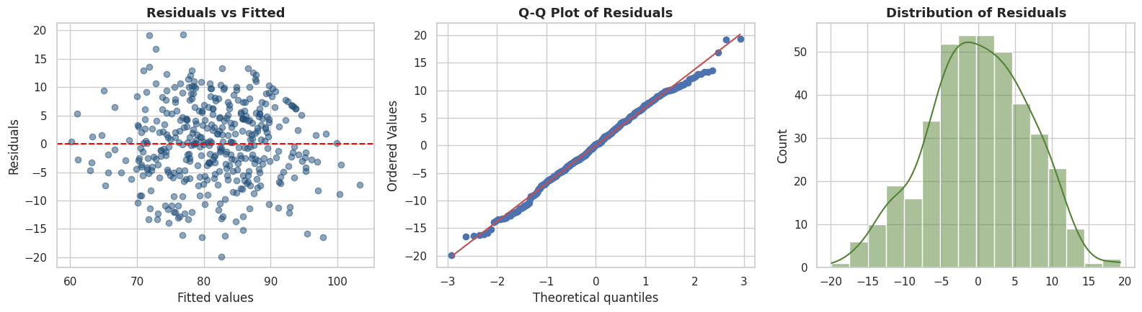
Chart output
Python code:
# 19.4 Breusch-Pagan test for heteroscedasticity (H0: residual variance is constant)
bp_stat, bp_pvalue, bp_fstat, bp_fpvalue = het_breuschpagan(residuals, multi_model.model.exog)
print(f"Breusch-Pagan test: LM statistic = {bp_stat:.3f}, p-value = {bp_pvalue:.4f}")
print("Conclusion:", "Reject H0 - evidence of heteroscedasticity." if bp_pvalue < 0.05
else "Fail to reject H0 - residual variance appears constant (homoscedastic).")
Line-by-line breakdown:
- 19.4 Breusch-Pagan test for heteroscedasticity (H0: residual variance is constant)
- bp_stat, bp_pvalue, bp_fstat, bp_fpvalue = het_breuschpagan(residuals, multi_model.model.exog) - Computes a value and stores it in the variable bp_stat, bp_pvalue, bp_fstat, bp_fpvalue for use in later lines.
- print(f"Breusch-Pagan test: LM statistic = {bp_stat:.3f}, p-value = {bp_pvalue:.4f}") - Prints a result to the notebook output so it can be read directly.
- print("Conclusion:", "Reject H0 - evidence of heteroscedasticity." if bp_pvalue < 0.05 - Prints a result to the notebook output so it can be read directly.
- else "Fail to reject H0 - residual variance appears constant (homoscedastic).") - Executes this statement as part of the step described above.
Output:
Breusch-Pagan test: LM statistic = 4.022, p-value = 0.6736
Conclusion: Fail to reject H0 - residual variance appears constant (homoscedastic).
Python code:
# 19.5 Variance Inflation Factor (VIF) - detects multicollinearity among predictors
X_vif = sm.add_constant(df[["YearsExperience", "TrainingHours", "AttendanceRate"]])
vif_data = pd.DataFrame({
"feature": X_vif.columns,
"VIF": [variance_inflation_factor(X_vif.values, i) for i in range(X_vif.shape[1])]
})
vif_data = vif_data[vif_data["feature"] != "const"]
vif_data
Line-by-line breakdown:
- 19.5 Variance Inflation Factor (VIF) - detects multicollinearity among predictors
- X_vif = sm.add_constant(df[["YearsExperience", "TrainingHours", "AttendanceRate"]]) - Computes a value and stores it in the variable X_vif for use in later lines.
- vif_data = pd.DataFrame({ - Computes a value and stores it in the variable vif_data for use in later lines.
- "feature": X_vif.columns, - Executes this statement as part of the step described above.
- "VIF": [variance_inflation_factor(X_vif.values, i) for i in range(X_vif.shape[1])] - Executes this statement as part of the step described above.
- }) - Executes this statement as part of the step described above.
- vif_data = vif_data[vif_data["feature"] != "const"] - Computes a value and stores it in the variable vif_data for use in later lines.
- vif_data - Executes this statement as part of the step described above.
Output:
feature VIF
1 YearsExperience 1.002449
2 TrainingHours 1.003050
3 AttendanceRate 1.001441
All VIF values well below 10 (typically below 5) indicate the predictors are not problematically collinear, so each coefficient in the multiple regression can be interpreted on its own.

20. Logistic Regression
Used when the outcome is binary (here, Promoted: 0 or 1). Logistic regression models the log-odds of the outcome as a linear function of the predictors, and predicted probabilities are squeezed into [0, 1] via the sigmoid function.
Python code:
# 20.1 Logistic regression with statsmodels - full inferential output (coefficients, p-values, odds ratios)
logit_model = smf.logit("Promoted ~ YearsExperience + PerformanceScore + TrainingHours", data=df).fit(disp=0)
print(logit_model.summary())
print("\nOdds ratios (exp(coefficient)):")
print(np.exp(logit_model.params))
Line-by-line breakdown:
- 20.1 Logistic regression with statsmodels - full inferential output (coefficients, p-values, odds ratios)
- logit_model = smf.logit("Promoted ~ YearsExperience + PerformanceScore + TrainingHours", data=df).fit(disp=0) - Computes a value and stores it in the variable logit_model for use in later lines.
- print(logit_model.summary()) - Prints a result to the notebook output so it can be read directly.
- print("\nOdds ratios (exp(coefficient)):") - Prints a result to the notebook output so it can be read directly.
- print(np.exp(logit_model.params)) - Prints a result to the notebook output so it can be read directly.
Output:
Logit Regression Results
==============================================================================
Dep. Variable: Promoted No. Observations: 400
Model: Logit Df Residuals: 396
Method: MLE Df Model: 3
Date: Fri, 28 Aug 2026 Pseudo R-squ.: 0.2136
Time: 10:49:16 Log-Likelihood: -207.27
converged: True LL-Null: -263.58
Covariance Type: nonrobust LLR p-value: 3.001e-24
====================================================================================
coef std err z P>|z| [0.025 0.975]
------------------------------------------------------------------------------------
Intercept -5.0340 1.057 -4.761 0.000 -7.106 -2.962
YearsExperience 0.3397 0.054 6.245 0.000 0.233 0.446
PerformanceScore 0.0310 0.016 1.965 0.049 8.63e-05 0.062
TrainingHours 0.0335 0.012 2.779 0.005 0.010 0.057
====================================================================================
Odds ratios (exp(coefficient)):
Intercept 0.006512
YearsExperience 1.404548
PerformanceScore 1.031481
TrainingHours 1.034097
dtype: float64
Interpreting an odds ratio: a value above 1 means an increase in that predictor is associated with higher odds of promotion; a value below 1 means the opposite. For example, an odds ratio of 1.15 on YearsExperience means each extra year of experience is associated with a 15% increase in the odds of being promoted, holding the other predictors constant.
Python code:
# 20.2 Logistic regression with scikit-learn, plus a full classification evaluation
X = df[["YearsExperience", "PerformanceScore", "TrainingHours"]]
y = df["Promoted"]
X_train, X_test, y_train, y_test = train_test_split(X, y, test_size=0.25, random_state=42, stratify=y)
clf = LogisticRegression()
clf.fit(X_train, y_train)
y_pred = clf.predict(X_test)
y_proba = clf.predict_proba(X_test)[:, 1]
print(f"Accuracy: {accuracy_score(y_test, y_pred):.3f}")
print("\nConfusion Matrix:")
print(confusion_matrix(y_test, y_pred))
print("\nClassification Report:")
print(classification_report(y_test, y_pred))
Line-by-line breakdown:
- 20.2 Logistic regression with scikit-learn, plus a full classification evaluation
- X = df[["YearsExperience", "PerformanceScore", "TrainingHours"]] - Computes a value and stores it in the variable X for use in later lines.
- y = df["Promoted"] - Computes a value and stores it in the variable y for use in later lines.
- X_train, X_test, y_train, y_test = train_test_split(X, y, test_size=0.25, random_state=42, stratify=y) - Computes a value and stores it in the variable X_train, X_test, y_train, y_test for use in later lines.
- clf = LogisticRegression() - Computes a value and stores it in the variable clf for use in later lines.
- clf.fit(X_train, y_train) - Executes this statement as part of the step described above.
- y_pred = clf.predict(X_test) - Computes a value and stores it in the variable y_pred for use in later lines.
- y_proba = clf.predict_proba(X_test)[:, 1] - Computes a value and stores it in the variable y_proba for use in later lines.
- print(f"Accuracy: {accuracy_score(y_test, y_pred):.3f}") - Prints a result to the notebook output so it can be read directly.
- print("\nConfusion Matrix:") - Prints a result to the notebook output so it can be read directly.
- print(confusion_matrix(y_test, y_pred)) - Prints a result to the notebook output so it can be read directly.
- print("\nClassification Report:") - Prints a result to the notebook output so it can be read directly.
- print(classification_report(y_test, y_pred)) - Prints a result to the notebook output so it can be read directly.
Output:
Accuracy: 0.690
Confusion Matrix:
[[17 20]
[11 52]]
Classification Report:
precision recall f1-score support
0 0.61 0.46 0.52 37
1 0.72 0.83 0.77 63
accuracy 0.69 100
macro avg 0.66 0.64 0.65 100
weighted avg 0.68 0.69 0.68 100
Python code:
# 20.3 ROC curve and AUC - overall discrimination ability of the classifier across all thresholds
from sklearn.metrics import roc_curve, roc_auc_score
fpr, tpr, thresholds = roc_curve(y_test, y_proba)
auc_score = roc_auc_score(y_test, y_proba)
fig, ax = plt.subplots()
ax.plot(fpr, tpr, color="#1F4E78", lw=2, label=f"ROC curve (AUC = {auc_score:.3f})")
ax.plot([0, 1], [0, 1], color="gray", linestyle="--", label="Random guess")
ax.set_xlabel("False Positive Rate"); ax.set_ylabel("True Positive Rate")
ax.set_title("ROC Curve - Logistic Regression for Promotion")
ax.legend()
plt.tight_layout(); plt.show()
Line-by-line breakdown:
- 20.3 ROC curve and AUC - overall discrimination ability of the classifier across all thresholds
- from sklearn.metrics import roc_curve, roc_auc_score - Imports the library or function needed for the step below.
- fpr, tpr, thresholds = roc_curve(y_test, y_proba) - Computes a value and stores it in the variable fpr, tpr, thresholds for use in later lines.
- auc_score = roc_auc_score(y_test, y_proba) - Computes a value and stores it in the variable auc_score for use in later lines.
- fig, ax = plt.subplots() - Creates a new Matplotlib figure and one or more axes to draw a chart on.
- ax.plot(fpr, tpr, color="#1F4E78", lw=2, label=f"ROC curve (AUC = {auc_score:.3f})") - Configures or draws on the chart (titles, labels, the plotted series, or reference lines).
- ax.plot([0, 1], [0, 1], color="gray", linestyle="--", label="Random guess") - Configures or draws on the chart (titles, labels, the plotted series, or reference lines).
- ax.set_xlabel("False Positive Rate"); ax.set_ylabel("True Positive Rate") - Configures or draws on the chart (titles, labels, the plotted series, or reference lines).
- ax.set_title("ROC Curve - Logistic Regression for Promotion") - Configures or draws on the chart (titles, labels, the plotted series, or reference lines).
- ax.legend() - Configures or draws on the chart (titles, labels, the plotted series, or reference lines).
- plt.tight_layout(); plt.show() - Adjusts the overall plot layout or renders it to the notebook.
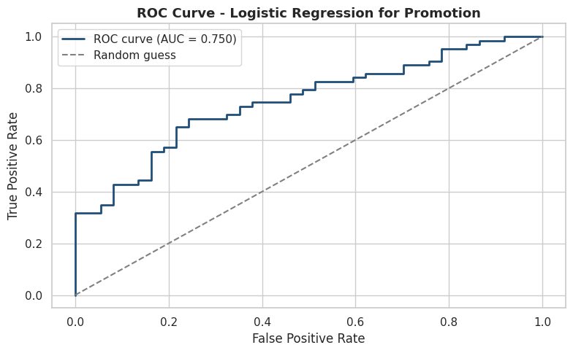
Chart output

21. Statistical Power and Sample Size
- Statistical power is the probability of correctly rejecting a false null hypothesis (avoiding a Type II error). Conventionally, 0.80 (80%) is considered adequate.
- Power analysis answers two practical questions: “how large a sample do I need to detect an effect of a given size?” and “what power did my study actually have?”
Python code:
power_analysis = TTestIndPower()
# 21.1 Required sample size to detect a medium effect (Cohen's d = 0.5) with 80% power, alpha = 0.05
required_n = power_analysis.solve_power(effect_size=0.5, alpha=0.05, power=0.80, ratio=1.0)
print(f"Required sample size PER GROUP to detect d=0.5 at alpha=0.05, power=0.80: {required_n:.1f}")
# 21.2 Achieved power of our actual Male-vs-Female PerformanceScore comparison
observed_d = cohens_d(male_scores, female_scores)
achieved_power = power_analysis.solve_power(
effect_size=abs(observed_d), nobs1=len(male_scores), alpha=0.05, ratio=len(female_scores)/len(male_scores)
)
print(f"Observed effect size (Cohen's d) = {observed_d:.3f}")
print(f"Achieved statistical power of our Male vs Female comparison = {achieved_power:.3f}")
Line-by-line breakdown:
- power_analysis = TTestIndPower() - Computes a value and stores it in the variable power_analysis for use in later lines.
- 21.1 Required sample size to detect a medium effect (Cohen’s d = 0.5) with 80% power, alpha = 0.05
- required_n = power_analysis.solve_power(effect_size=0.5, alpha=0.05, power=0.80, ratio=1.0) - Computes a value and stores it in the variable required_n for use in later lines.
- print(f"Required sample size PER GROUP to detect d=0.5 at alpha=0.05, power=0.80: {required_n:.1f}") - Prints a result to the notebook output so it can be read directly.
- 21.2 Achieved power of our actual Male-vs-Female PerformanceScore comparison
- observed_d = cohens_d(male_scores, female_scores) - Computes a value and stores it in the variable observed_d for use in later lines.
- achieved_power = power_analysis.solve_power( - Computes a value and stores it in the variable achieved_power for use in later lines.
- effect_size=abs(observed_d), nobs1=len(male_scores), alpha=0.05, ratio=len(female_scores)/len(male_scores) - Computes a value and stores it in the variable effect_size for use in later lines.
- ) - Executes this statement as part of the step described above.
- print(f"Observed effect size (Cohen's d) = {observed_d:.3f}") - Prints a result to the notebook output so it can be read directly.
- print(f"Achieved statistical power of our Male vs Female comparison = {achieved_power:.3f}") - Prints a result to the notebook output so it can be read directly.
Output:
Required sample size PER GROUP to detect d=0.5 at alpha=0.05, power=0.80: 63.8
Observed effect size (Cohen's d) = -0.212
Achieved statistical power of our Male vs Female comparison = 0.561
Python code:
# 21.3 Power curve: how power changes with sample size, for a few effect sizes
sample_sizes = np.arange(10, 300, 10)
fig, ax = plt.subplots()
for effect in [0.2, 0.5, 0.8]:
powers = [power_analysis.solve_power(effect_size=effect, nobs1=n, alpha=0.05) for n in sample_sizes]
ax.plot(sample_sizes, powers, label=f"effect size = {effect}")
ax.axhline(0.8, color="gray", linestyle="--", label="80% power threshold")
ax.set_xlabel("Sample size per group"); ax.set_ylabel("Statistical power")
ax.set_title("Power Curves for Different Effect Sizes")
ax.legend()
plt.tight_layout(); plt.show()
Line-by-line breakdown:
- 21.3 Power curve: how power changes with sample size, for a few effect sizes
- sample_sizes = np.arange(10, 300, 10) - Computes a value and stores it in the variable sample_sizes for use in later lines.
- fig, ax = plt.subplots() - Creates a new Matplotlib figure and one or more axes to draw a chart on.
- for effect in [0.2, 0.5, 0.8]: - Loops over a sequence, repeating the indented statements for each item.
- powers = [power_analysis.solve_power(effect_size=effect, nobs1=n, alpha=0.05) for n in sample_sizes] - Computes a value and stores it in the variable powers for use in later lines.
- ax.plot(sample_sizes, powers, label=f"effect size = {effect}") - Configures or draws on the chart (titles, labels, the plotted series, or reference lines).
- ax.axhline(0.8, color="gray", linestyle="--", label="80% power threshold") - Configures or draws on the chart (titles, labels, the plotted series, or reference lines).
- ax.set_xlabel("Sample size per group"); ax.set_ylabel("Statistical power") - Configures or draws on the chart (titles, labels, the plotted series, or reference lines).
- ax.set_title("Power Curves for Different Effect Sizes") - Configures or draws on the chart (titles, labels, the plotted series, or reference lines).
- ax.legend() - Configures or draws on the chart (titles, labels, the plotted series, or reference lines).
- plt.tight_layout(); plt.show() - Adjusts the overall plot layout or renders it to the notebook.
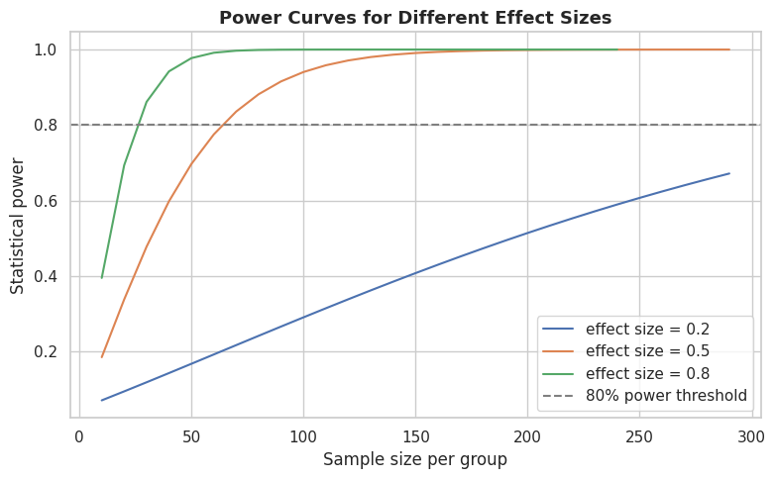
Chart output

22. Bootstrapping and Resampling
Bootstrapping estimates the sampling distribution of a statistic by repeatedly resampling with replacement from the observed data. It requires no distributional assumptions and works for almost any statistic (mean, median, correlation, regression coefficient, etc.).
Python code:
# 22.1 Bootstrap confidence interval for the median of MonthlySales (robust to the outliers we injected)
n_bootstrap = 5000
bootstrap_medians = np.empty(n_bootstrap)
data = df["MonthlySales"].values
for i in range(n_bootstrap):
resample = RNG.choice(data, size=len(data), replace=True)
bootstrap_medians[i] = np.median(resample)
ci_lower, ci_upper = np.percentile(bootstrap_medians, [2.5, 97.5])
print(f"Observed median MonthlySales: {np.median(data):.2f}")
print(f"Bootstrap 95% CI for the median: ({ci_lower:.2f}, {ci_upper:.2f})")
fig, ax = plt.subplots()
sns.histplot(bootstrap_medians, kde=True, ax=ax, color="#7030A0")
ax.axvline(ci_lower, color="red", linestyle="--")
ax.axvline(ci_upper, color="red", linestyle="--")
ax.set_title(f"Bootstrap Distribution of the Median MonthlySales ({n_bootstrap} resamples)")
plt.tight_layout(); plt.show()
Line-by-line breakdown:
- 22.1 Bootstrap confidence interval for the median of MonthlySales (robust to the outliers we injected)
- n_bootstrap = 5000 - Computes a value and stores it in the variable n_bootstrap for use in later lines.
- bootstrap_medians = np.empty(n_bootstrap) - Computes a value and stores it in the variable bootstrap_medians for use in later lines.
- data = df["MonthlySales"].values - Computes a value and stores it in the variable data for use in later lines.
- for i in range(n_bootstrap): - Loops over a sequence, repeating the indented statements for each item.
- resample = RNG.choice(data, size=len(data), replace=True) - Computes a value and stores it in the variable resample for use in later lines.
- bootstrap_medians[i] = np.median(resample) - Computes a value and stores it in the variable bootstrap_medians[i] for use in later lines.
- ci_lower, ci_upper = np.percentile(bootstrap_medians, [2.5, 97.5]) - Computes a value and stores it in the variable ci_lower, ci_upper for use in later lines.
- print(f"Observed median MonthlySales: {np.median(data):.2f}") - Prints a result to the notebook output so it can be read directly.
- print(f"Bootstrap 95% CI for the median: ({ci_lower:.2f}, {ci_upper:.2f})") - Prints a result to the notebook output so it can be read directly.
- fig, ax = plt.subplots() - Creates a new Matplotlib figure and one or more axes to draw a chart on.
- sns.histplot(bootstrap_medians, kde=True, ax=ax, color="#7030A0") - Draws a seaborn statistical chart from the DataFrame.
- ax.axvline(ci_lower, color="red", linestyle="--") - Configures or draws on the chart (titles, labels, the plotted series, or reference lines).
- ax.axvline(ci_upper, color="red", linestyle="--") - Configures or draws on the chart (titles, labels, the plotted series, or reference lines).
- ax.set_title(f"Bootstrap Distribution of the Median MonthlySales ({n_bootstrap} resamples)") - Configures or draws on the chart (titles, labels, the plotted series, or reference lines).
- plt.tight_layout(); plt.show() - Adjusts the overall plot layout or renders it to the notebook.
Output:
Observed median MonthlySales: 6269.75
Bootstrap 95% CI for the median: (6125.75, 6467.86)
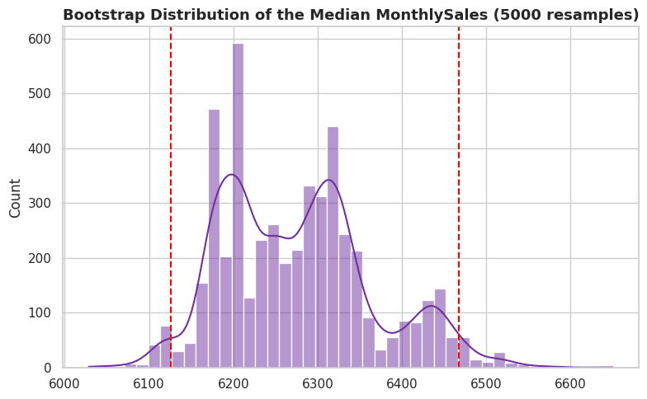
Chart output
Python code:
# 22.2 Bootstrap hypothesis test: is the difference in mean PerformanceScore (Male - Female) real?
observed_diff = male_scores.mean() - female_scores.mean()
combined = np.concatenate([male_scores.values, female_scores.values])
n_male = len(male_scores)
n_boot = 5000
boot_diffs = np.empty(n_boot)
for i in range(n_boot):
shuffled = RNG.permutation(combined)
boot_diffs[i] = shuffled[:n_male].mean() - shuffled[n_male:].mean()
# Two-sided permutation p-value: how often does a random relabelling produce a difference
# at least as extreme as the one we actually observed?
p_value_perm = np.mean(np.abs(boot_diffs) >= np.abs(observed_diff))
print(f"Observed difference in means (Male - Female): {observed_diff:.3f}")
print(f"Permutation-test p-value: {p_value_perm:.4f}")
print("Conclusion:", "Reject H0 (matches the parametric t-test result)." if p_value_perm < 0.05
else "Fail to reject H0.")
Line-by-line breakdown:
- 22.2 Bootstrap hypothesis test: is the difference in mean PerformanceScore (Male - Female) real?
- observed_diff = male_scores.mean() - female_scores.mean() - Computes a value and stores it in the variable observed_diff for use in later lines.
- combined = np.concatenate([male_scores.values, female_scores.values]) - Computes a value and stores it in the variable combined for use in later lines.
- n_male = len(male_scores) - Computes a value and stores it in the variable n_male for use in later lines.
- n_boot = 5000 - Computes a value and stores it in the variable n_boot for use in later lines.
- boot_diffs = np.empty(n_boot) - Computes a value and stores it in the variable boot_diffs for use in later lines.
- for i in range(n_boot): - Loops over a sequence, repeating the indented statements for each item.
- shuffled = RNG.permutation(combined) - Computes a value and stores it in the variable shuffled for use in later lines.
- boot_diffs[i] = shuffled[:n_male].mean() - shuffled[n_male:].mean() - Computes a value and stores it in the variable boot_diffs[i] for use in later lines.
- Two-sided permutation p-value: how often does a random relabelling produce a difference
- at least as extreme as the one we actually observed?
- p_value_perm = np.mean(np.abs(boot_diffs) >= np.abs(observed_diff)) - Computes a value and stores it in the variable p_value_perm for use in later lines.
- print(f"Observed difference in means (Male - Female): {observed_diff:.3f}") - Prints a result to the notebook output so it can be read directly.
- print(f"Permutation-test p-value: {p_value_perm:.4f}") - Prints a result to the notebook output so it can be read directly.
- print("Conclusion:", "Reject H0 (matches the parametric t-test result)." if p_value_perm < 0.05 - Prints a result to the notebook output so it can be read directly.
- else "Fail to reject H0.") - Executes this statement as part of the step described above.
Output:
Observed difference in means (Male - Female): -2.168
Permutation-test p-value: 0.0354
Conclusion: Reject H0 (matches the parametric t-test result).

23. Bayesian Statistics - A Practical Introduction
Bayesian statistics updates a prior belief about a parameter with observed data to produce a posterior belief, using Bayes’ theorem:
$$P\left(θ∣\text{data}\right)=\frac{P\left(\text{data}∣θ\right) P\left(θ\right)}{P\left(\text{data}\right)}$$
For a proportion (like the promotion rate), the Beta distribution is the natural “conjugate prior”: starting with a Beta prior and observing binomial data yields a Beta posterior in closed form.
Python code:
# 23.1 Bayesian estimation of the promotion rate using a Beta-Binomial conjugate model
prior_alpha, prior_beta = 2, 2 # a mild, weakly-informative prior centred on 0.5
successes = df["Promoted"].sum()
failures = len(df) - successes
posterior_alpha = prior_alpha + successes
posterior_beta = prior_beta + failures
x = np.linspace(0, 1, 500)
prior_pdf = stats.beta.pdf(x, prior_alpha, prior_beta)
posterior_pdf = stats.beta.pdf(x, posterior_alpha, posterior_beta)
fig, ax = plt.subplots()
ax.plot(x, prior_pdf, label="Prior belief", color="gray", linestyle="--")
ax.plot(x, posterior_pdf, label="Posterior belief (after seeing data)", color="#1F4E78", lw=2)
ax.axvline(successes / len(df), color="red", linestyle=":", label="Observed sample proportion")
ax.set_xlabel("Promotion rate"); ax.set_ylabel("Density")
ax.set_title("Bayesian Beta-Binomial Update for the Promotion Rate")
ax.legend()
plt.tight_layout(); plt.show()
posterior_mean = posterior_alpha / (posterior_alpha + posterior_beta)
credible_interval = stats.beta.interval(0.95, posterior_alpha, posterior_beta)
print(f"Posterior mean estimate of the promotion rate: {posterior_mean:.3f}")
print(f"95% credible interval: ({credible_interval[0]:.3f}, {credible_interval[1]:.3f})")
Line-by-line breakdown:
- 23.1 Bayesian estimation of the promotion rate using a Beta-Binomial conjugate model
- prior_alpha, prior_beta = 2, 2 - a mild, weakly-informative prior centred on 0.5
- successes = df["Promoted"].sum() - Computes a value and stores it in the variable successes for use in later lines.
- failures = len(df) - successes - Computes a value and stores it in the variable failures for use in later lines.
- posterior_alpha = prior_alpha + successes - Computes a value and stores it in the variable posterior_alpha for use in later lines.
- posterior_beta = prior_beta + failures - Computes a value and stores it in the variable posterior_beta for use in later lines.
- x = np.linspace(0, 1, 500) - Computes a value and stores it in the variable x for use in later lines.
- prior_pdf = stats.beta.pdf(x, prior_alpha, prior_beta) - Computes a value and stores it in the variable prior_pdf for use in later lines.
- posterior_pdf = stats.beta.pdf(x, posterior_alpha, posterior_beta) - Computes a value and stores it in the variable posterior_pdf for use in later lines.
- fig, ax = plt.subplots() - Creates a new Matplotlib figure and one or more axes to draw a chart on.
- ax.plot(x, prior_pdf, label="Prior belief", color="gray", linestyle="--") - Configures or draws on the chart (titles, labels, the plotted series, or reference lines).
- ax.plot(x, posterior_pdf, label="Posterior belief (after seeing data)", color="#1F4E78", lw=2) - Configures or draws on the chart (titles, labels, the plotted series, or reference lines).
- ax.axvline(successes / len(df), color="red", linestyle=":", label="Observed sample proportion") - Configures or draws on the chart (titles, labels, the plotted series, or reference lines).
- ax.set_xlabel("Promotion rate"); ax.set_ylabel("Density") - Configures or draws on the chart (titles, labels, the plotted series, or reference lines).
- ax.set_title("Bayesian Beta-Binomial Update for the Promotion Rate") - Configures or draws on the chart (titles, labels, the plotted series, or reference lines).
- ax.legend() - Configures or draws on the chart (titles, labels, the plotted series, or reference lines).
- plt.tight_layout(); plt.show() - Adjusts the overall plot layout or renders it to the notebook.
- posterior_mean = posterior_alpha / (posterior_alpha + posterior_beta) - Computes a value and stores it in the variable posterior_mean for use in later lines.
- credible_interval = stats.beta.interval(0.95, posterior_alpha, posterior_beta) - Computes a value and stores it in the variable credible_interval for use in later lines.
- print(f"Posterior mean estimate of the promotion rate: {posterior_mean:.3f}") - Prints a result to the notebook output so it can be read directly.
- print(f"95% credible interval: ({credible_interval[0]:.3f}, {credible_interval[1]:.3f})") - Prints a result to the notebook output so it can be read directly.
Output:
Posterior mean estimate of the promotion rate: 0.629
95% credible interval: (0.581, 0.675)
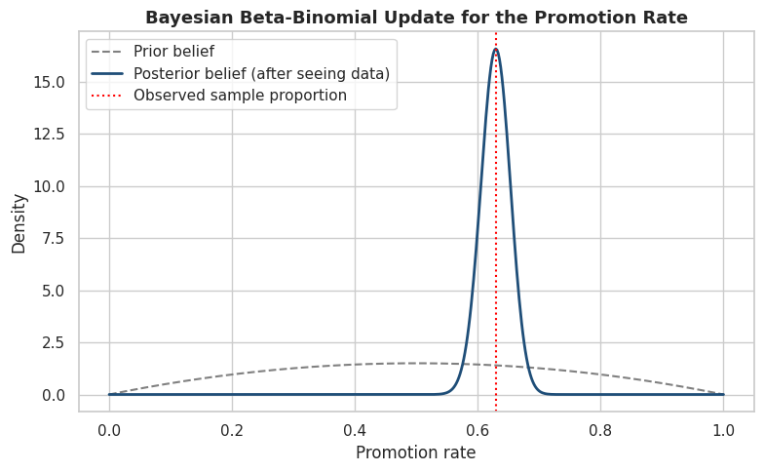
Chart output
Confidence interval vs. credible interval: a 95% frequentist confidence interval means “95% of intervals built this way, across repeated sampling, would contain the true value.” A 95% Bayesian credible interval means “given the data and prior, there is a 95% probability the true value lies in this range” - a more direct and often more intuitive statement.

24. Time Series Analysis
We switch to the second dataset, monthly_revenue_timeseries.csv, to cover time-series-specific statistics: trend/seasonality decomposition, autocorrelation, and stationarity testing.
Python code:
ts = pd.read_csv("monthly_revenue_timeseries.csv", parse_dates=["Date"])
ts = ts.set_index("Date")
ts.index.freq = "MS" # tell pandas/statsmodels this is a monthly-start series
ts.head()
Line-by-line breakdown:
- ts = pd.read_csv("monthly_revenue_timeseries.csv", parse_dates=["Date"]) - Computes a value and stores it in the variable ts for use in later lines.
- ts = ts.set_index("Date") - Computes a value and stores it in the variable ts for use in later lines.
- ts.index.freq = "MS" - tell pandas/statsmodels this is a monthly-start series
- ts.head() - Executes this statement as part of the step described above.
Output:
MonthlyRevenue MarketingSpend UnitsSold
Date
2020-01-01 15802.19 2001.85 393
2020-02-01 16186.81 2272.19 379
2020-03-01 17881.72 2501.13 403
2020-04-01 17799.53 2551.06 427
2020-05-01 17581.83 2400.32 391
Python code:
fig, ax = plt.subplots(figsize=(11, 4.5))
ax.plot(ts.index, ts["MonthlyRevenue"], color="#1F4E78")
ax.set_title("Monthly Revenue Over Time")
ax.set_ylabel("Revenue")
plt.tight_layout(); plt.show()
Line-by-line breakdown:
- fig, ax = plt.subplots(figsize=(11, 4.5)) - Creates a new Matplotlib figure and one or more axes to draw a chart on.
- ax.plot(ts.index, ts["MonthlyRevenue"], color="#1F4E78") - Configures or draws on the chart (titles, labels, the plotted series, or reference lines).
- ax.set_title("Monthly Revenue Over Time") - Configures or draws on the chart (titles, labels, the plotted series, or reference lines).
- ax.set_ylabel("Revenue") - Configures or draws on the chart (titles, labels, the plotted series, or reference lines).
- plt.tight_layout(); plt.show() - Adjusts the overall plot layout or renders it to the notebook.
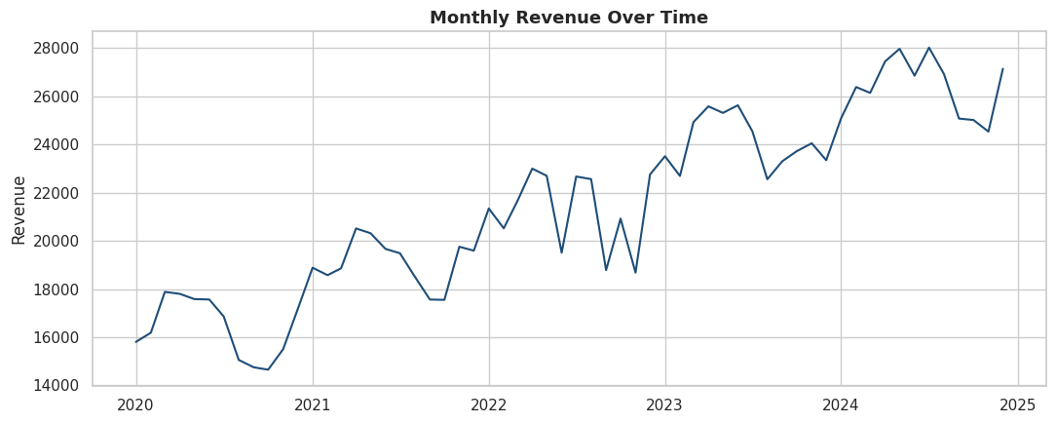
Chart output
Python code:
# 24.1 Moving average smoothing - a simple way to visualise the underlying trend
ts["MA_3"] = ts["MonthlyRevenue"].rolling(window=3).mean()
ts["MA_12"] = ts["MonthlyRevenue"].rolling(window=12).mean()
fig, ax = plt.subplots(figsize=(11, 4.5))
ax.plot(ts.index, ts["MonthlyRevenue"], label="Actual", alpha=0.5, color="gray")
ax.plot(ts.index, ts["MA_3"], label="3-month moving average", color="#2E75B6")
ax.plot(ts.index, ts["MA_12"], label="12-month moving average", color="#C00000", lw=2)
ax.set_title("Monthly Revenue with Moving Averages")
ax.legend()
plt.tight_layout(); plt.show()
Line-by-line breakdown:
- 24.1 Moving average smoothing - a simple way to visualise the underlying trend
- ts["MA_3"] = ts["MonthlyRevenue"].rolling(window=3).mean() - Computes a value and stores it in the variable ts["MA_3"] for use in later lines.
- ts["MA_12"] = ts["MonthlyRevenue"].rolling(window=12).mean() - Computes a value and stores it in the variable ts["MA_12"] for use in later lines.
- fig, ax = plt.subplots(figsize=(11, 4.5)) - Creates a new Matplotlib figure and one or more axes to draw a chart on.
- ax.plot(ts.index, ts["MonthlyRevenue"], label="Actual", alpha=0.5, color="gray") - Configures or draws on the chart (titles, labels, the plotted series, or reference lines).
- ax.plot(ts.index, ts["MA_3"], label="3-month moving average", color="#2E75B6") - Configures or draws on the chart (titles, labels, the plotted series, or reference lines).
- ax.plot(ts.index, ts["MA_12"], label="12-month moving average", color="#C00000", lw=2) - Configures or draws on the chart (titles, labels, the plotted series, or reference lines).
- ax.set_title("Monthly Revenue with Moving Averages") - Configures or draws on the chart (titles, labels, the plotted series, or reference lines).
- ax.legend() - Configures or draws on the chart (titles, labels, the plotted series, or reference lines).
- plt.tight_layout(); plt.show() - Adjusts the overall plot layout or renders it to the notebook.
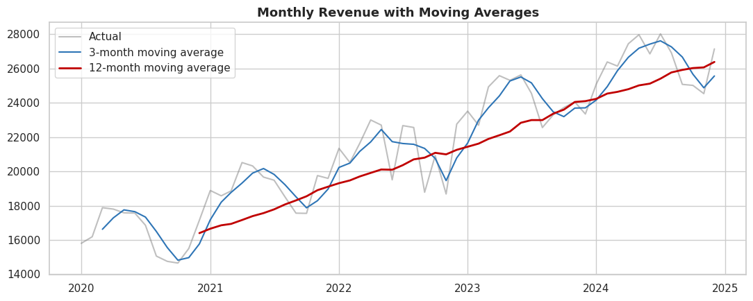
Chart output
Python code:
# 24.2 Classical decomposition into Trend, Seasonal, and Residual components
decomposition = seasonal_decompose(ts["MonthlyRevenue"], model="additive", period=12)
fig = decomposition.plot()
fig.set_size_inches(11, 8)
plt.tight_layout(); plt.show()
Line-by-line breakdown:
- 24.2 Classical decomposition into Trend, Seasonal, and Residual components
- decomposition = seasonal_decompose(ts["MonthlyRevenue"], model="additive", period=12) - Computes a value and stores it in the variable decomposition for use in later lines.
- fig = decomposition.plot() - Computes a value and stores it in the variable fig for use in later lines.
- fig.set_size_inches(11, 8) - Executes this statement as part of the step described above.
- plt.tight_layout(); plt.show() - Adjusts the overall plot layout or renders it to the notebook.
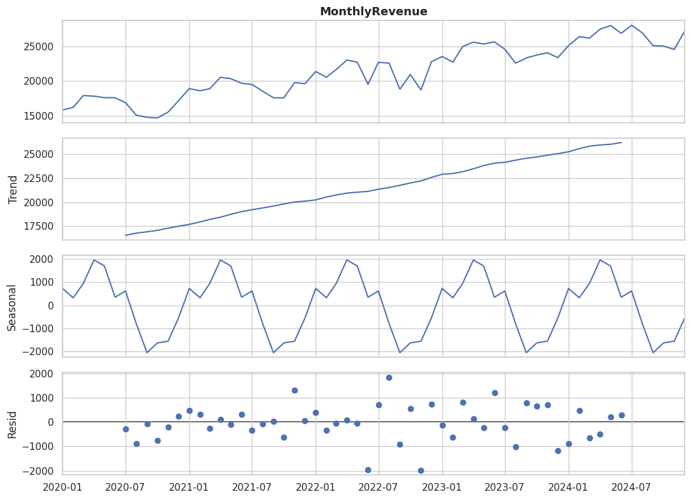
Chart output
Python code:
# 24.3 Augmented Dickey-Fuller (ADF) test for stationarity
# H0: the series has a unit root (i.e. it is NON-stationary)
adf_stat, adf_p, used_lag, n_obs, crit_values, icbest = adfuller(ts["MonthlyRevenue"])
print(f"ADF statistic = {adf_stat:.3f}, p-value = {adf_p:.4f}")
print("Critical values:", {k: round(v, 3) for k, v in crit_values.items()})
print("Conclusion:", "Reject H0 - the series is stationary." if adf_p < 0.05
else "Fail to reject H0 - the series is likely non-stationary (has trend/seasonality), "
"consistent with what we see in the decomposition above.")
Line-by-line breakdown:
- 24.3 Augmented Dickey-Fuller (ADF) test for stationarity
- H0: the series has a unit root (i.e. it is NON-stationary)
- adf_stat, adf_p, used_lag, n_obs, crit_values, icbest = adfuller(ts["MonthlyRevenue"]) - Computes a value and stores it in the variable adf_stat, adf_p, used_lag, n_obs, crit_values, icbest for use in later lines.
- print(f"ADF statistic = {adf_stat:.3f}, p-value = {adf_p:.4f}") - Prints a result to the notebook output so it can be read directly.
- print("Critical values:", {k: round(v, 3) for k, v in crit_values.items()}) - Prints a result to the notebook output so it can be read directly.
- print("Conclusion:", "Reject H0 - the series is stationary." if adf_p < 0.05 - Prints a result to the notebook output so it can be read directly.
- else "Fail to reject H0 - the series is likely non-stationary (has trend/seasonality), " - Executes this statement as part of the step described above.
- "consistent with what we see in the decomposition above.") - Executes this statement as part of the step described above.
Output:
ADF statistic = -0.728, p-value = 0.8393
Critical values: {'1%': np.float64(-3.571), '5%': np.float64(-2.923), '10%': np.float64(-2.599)}
Conclusion: Fail to reject H0 - the series is likely non-stationary (has trend/seasonality), consistent with what we see in the decomposition above.
Python code:
# 24.4 Differencing to achieve stationarity when a series is non-stationary
ts["Revenue_diff"] = ts["MonthlyRevenue"].diff()
adf_stat2, adf_p2, *_ = adfuller(ts["Revenue_diff"].dropna())
print(f"ADF test on first-differenced series: statistic={adf_stat2:.3f}, p-value={adf_p2:.4f}")
print("Conclusion:", "Now stationary after differencing." if adf_p2 < 0.05 else "Still non-stationary.")
fig, ax = plt.subplots(figsize=(11, 4))
ax.plot(ts.index, ts["Revenue_diff"], color="#548235")
ax.axhline(0, color="black", linewidth=0.8)
ax.set_title("First-Differenced Monthly Revenue")
plt.tight_layout(); plt.show()
Line-by-line breakdown:
- 24.4 Differencing to achieve stationarity when a series is non-stationary
- ts["Revenue_diff"] = ts["MonthlyRevenue"].diff() - Computes a value and stores it in the variable ts["Revenue_diff"] for use in later lines.
- adf_stat2, adf_p2, *_ = adfuller(ts["Revenue_diff"].dropna()) - Computes a value and stores it in the variable adf_stat2, adf_p2, *_ for use in later lines.
- print(f"ADF test on first-differenced series: statistic={adf_stat2:.3f}, p-value={adf_p2:.4f}") - Prints a result to the notebook output so it can be read directly.
- print("Conclusion:", "Now stationary after differencing." if adf_p2 < 0.05 else "Still non-stationary.") - Prints a result to the notebook output so it can be read directly.
- fig, ax = plt.subplots(figsize=(11, 4)) - Creates a new Matplotlib figure and one or more axes to draw a chart on.
- ax.plot(ts.index, ts["Revenue_diff"], color="#548235") - Configures or draws on the chart (titles, labels, the plotted series, or reference lines).
- ax.axhline(0, color="black", linewidth=0.8) - Configures or draws on the chart (titles, labels, the plotted series, or reference lines).
- ax.set_title("First-Differenced Monthly Revenue") - Configures or draws on the chart (titles, labels, the plotted series, or reference lines).
- plt.tight_layout(); plt.show() - Adjusts the overall plot layout or renders it to the notebook.
Output:
ADF test on first-differenced series: statistic=-5.601, p-value=0.0000
Conclusion: Now stationary after differencing.
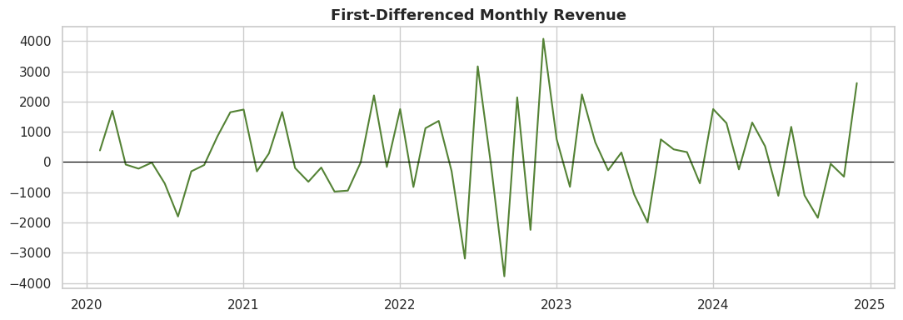
Chart output
Python code:
# 24.5 Autocorrelation (ACF) and Partial Autocorrelation (PACF) plots
# ACF: correlation of the series with its own lagged values.
# PACF: correlation of the series with a lag, after removing the effect of shorter lags.
fig, axes = plt.subplots(1, 2, figsize=(13, 4.5))
plot_acf(ts["MonthlyRevenue"], lags=24, ax=axes[0])
axes[0].set_title("Autocorrelation Function (ACF)")
plot_pacf(ts["MonthlyRevenue"], lags=24, ax=axes[1], method="ywm")
axes[1].set_title("Partial Autocorrelation Function (PACF)")
plt.tight_layout(); plt.show()
Line-by-line breakdown:
- 24.5 Autocorrelation (ACF) and Partial Autocorrelation (PACF) plots
- ACF: correlation of the series with its own lagged values.
- PACF: correlation of the series with a lag, after removing the effect of shorter lags.
- fig, axes = plt.subplots(1, 2, figsize=(13, 4.5)) - Creates a new Matplotlib figure and one or more axes to draw a chart on.
- plot_acf(ts["MonthlyRevenue"], lags=24, ax=axes[0]) - Computes a value and stores it in the variable plot_acf(ts["MonthlyRevenue"], lags for use in later lines.
- axes[0].set_title("Autocorrelation Function (ACF)") - Configures or draws on the chart (titles, labels, the plotted series, or reference lines).
- plot_pacf(ts["MonthlyRevenue"], lags=24, ax=axes[1], method="ywm") - Computes a value and stores it in the variable plot_pacf(ts["MonthlyRevenue"], lags for use in later lines.
- axes[1].set_title("Partial Autocorrelation Function (PACF)") - Configures or draws on the chart (titles, labels, the plotted series, or reference lines).
- plt.tight_layout(); plt.show() - Adjusts the overall plot layout or renders it to the notebook.
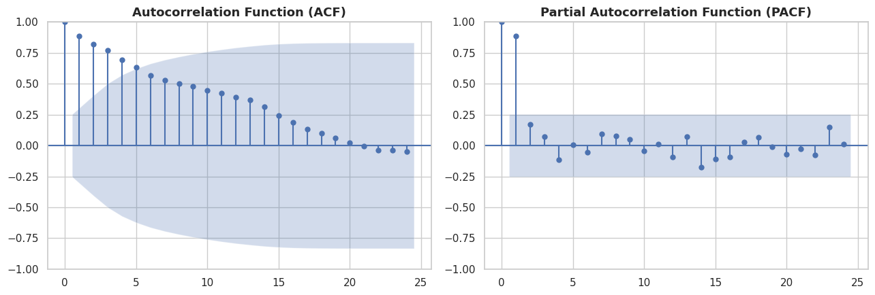
Chart output
Python code:
# 24.6 A simple forecast using Holt-Winters Exponential Smoothing (level + trend + seasonality)
from statsmodels.tsa.holtwinters import ExponentialSmoothing
hw_model = ExponentialSmoothing(
ts["MonthlyRevenue"], trend="add", seasonal="add", seasonal_periods=12
).fit()
forecast_horizon = 12
forecast = hw_model.forecast(forecast_horizon)
fig, ax = plt.subplots(figsize=(11, 4.5))
ax.plot(ts.index, ts["MonthlyRevenue"], label="Historical", color="#1F4E78")
ax.plot(forecast.index, forecast, label="12-month forecast", color="#C00000", linestyle="--", marker="o")
ax.set_title("Holt-Winters Forecast of Monthly Revenue (next 12 months)")
ax.legend()
plt.tight_layout(); plt.show()
forecast.round(2)
Line-by-line breakdown:
- 24.6 A simple forecast using Holt-Winters Exponential Smoothing (level + trend + seasonality)
- from statsmodels.tsa.holtwinters import ExponentialSmoothing - Imports the library or function needed for the step below.
- hw_model = ExponentialSmoothing( - Computes a value and stores it in the variable hw_model for use in later lines.
- ts["MonthlyRevenue"], trend="add", seasonal="add", seasonal_periods=12 - Computes a value and stores it in the variable ts["MonthlyRevenue"], trend for use in later lines.
- ).fit() - Executes this statement as part of the step described above.
- forecast_horizon = 12 - Computes a value and stores it in the variable forecast_horizon for use in later lines.
- forecast = hw_model.forecast(forecast_horizon) - Computes a value and stores it in the variable forecast for use in later lines.
- fig, ax = plt.subplots(figsize=(11, 4.5)) - Creates a new Matplotlib figure and one or more axes to draw a chart on.
- ax.plot(ts.index, ts["MonthlyRevenue"], label="Historical", color="#1F4E78") - Configures or draws on the chart (titles, labels, the plotted series, or reference lines).
- ax.plot(forecast.index, forecast, label="12-month forecast", color="#C00000", linestyle="--", marker="o") - Configures or draws on the chart (titles, labels, the plotted series, or reference lines).
- ax.set_title("Holt-Winters Forecast of Monthly Revenue (next 12 months)") - Configures or draws on the chart (titles, labels, the plotted series, or reference lines).
- ax.legend() - Configures or draws on the chart (titles, labels, the plotted series, or reference lines).
- plt.tight_layout(); plt.show() - Adjusts the overall plot layout or renders it to the notebook.
- forecast.round(2) - Executes this statement as part of the step described above.
Output:
2025-01-01 28420.09
2025-02-01 28364.09
2025-03-01 29382.60
2025-04-01 30361.40
2025-05-01 30268.79
2025-06-01 29336.56
2025-07-01 29809.33
2025-08-01 28612.24
2025-09-01 27387.02
2025-10-01 27864.78
2025-11-01 27996.24
2025-12-01 29489.73
Freq: MS, dtype: float64
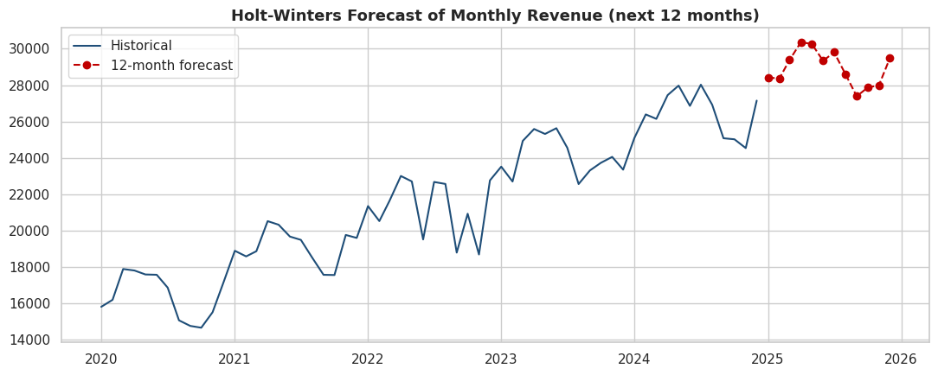
Chart output

25. Cheat Sheet and Reference Summary
Goal | Test / Method | Python function
Summarise one numeric variable | Descriptive statistics | Series.describe(), .mean(), .median(), .std()
Compare one mean to a fixed value | One-sample t-test | scipy.stats.ttest_1samp
Compare two independent group means | Independent t-test | scipy.stats.ttest_ind
Compare two independent group means (non-normal) | Mann-Whitney U | scipy.stats.mannwhitneyu
Compare before/after on the same subjects | Paired t-test | scipy.stats.ttest_rel
Compare before/after (non-normal) | Wilcoxon signed-rank | scipy.stats.wilcoxon
Compare 3+ group means | One-way ANOVA | scipy.stats.f_oneway, statsmodels.anova_lm
Compare 3+ group means (non-normal) | Kruskal-Wallis | scipy.stats.kruskal
Which pairs differ after ANOVA | Tukey HSD | statsmodels...pairwise_tukeyhsd
Test two categorical variables for association | Chi-square independence | scipy.stats.chi2_contingency
Test if observed categories match expected | Chi-square goodness of fit | scipy.stats.chisquare
Test if data is normally distributed | Shapiro-Wilk / KS / Anderson-Darling | scipy.stats.shapiro, .kstest, .anderson
Test if group variances are equal | Levene’s / Bartlett’s test | scipy.stats.levene, .bartlett
Measure linear/monotonic relationship | Correlation | scipy.stats.pearsonr, .spearmanr, .kendalltau
Predict a numeric outcome | Linear regression | statsmodels.formula.api.ols, sklearn.linear_model.LinearRegression
Predict a binary outcome | Logistic regression | statsmodels.formula.api.logit, sklearn.linear_model.LogisticRegression
Check multicollinearity | Variance Inflation Factor | statsmodels...variance_inflation_factor
Estimate a statistic’s uncertainty, assumption-free | Bootstrapping | manual resampling loop, shown above
Determine adequate sample size | Power analysis | statsmodels.stats.power.TTestIndPower
Decompose trend/seasonality in a time series | Seasonal decomposition | statsmodels...seasonal_decompose
Test if a time series is stationary | Augmented Dickey-Fuller | statsmodels.tsa.stattools.adfuller
Forecast a time series | Holt-Winters / ARIMA | statsmodels.tsa.holtwinters.ExponentialSmoothing

26. Conclusion
This notebook walked through the full practical arc of statistical analytics in Python:
- Descriptive statistics and visualization to understand a dataset.
- Probability distributions to model uncertainty.
- Inferential statistics (confidence intervals, hypothesis tests, ANOVA, non-parametric tests, chi-square tests) to draw conclusions about a population from a sample.
- Correlation and regression (linear and logistic) to model relationships and make predictions.
- Diagnostics (normality, equal variance, multicollinearity, heteroscedasticity) to validate every assumption behind those models.
- Effect size and power analysis to judge practical significance and design better studies.
- Bootstrapping and Bayesian methods as modern, assumption-light alternatives to classical tests.
- Time series analysis to handle data that unfolds over time.
Use this notebook together with the companion Excel workbook, CSV files, Word document, and HTML guide as a complete practical training kit.

Prepared by: Kajola Gbenga Data Scientist & AI Engineer

Document Information
- Title: Python Statistical Analytics - Comprehensive Practical Training Guide
- Prepared by: Kajola Gbenga
- Role: Data Scientist & AI Engineer
- Companion files: employee_statistics_dataset.csv, monthly_revenue_timeseries.csv, python_statistical_analytics_workbook.xlsx, Python_Statistical_Analytics_Practical.ipynb, Python_Statistical_Analytics_Guide.html

